# HEALTH FINANCING SITUATION ANALYSIS REPORT

**Domestic Resource Mobilization for Key**

**Populations (KPs) and Adolescents, Girls &**

**Young Women (AGYW) in Kenya**

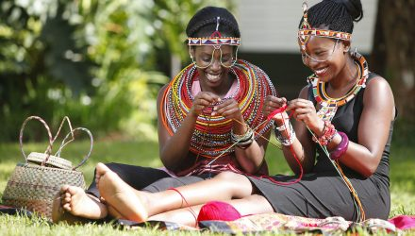

[This Photo](http://brewminate.com/sociological-perspective-and-the-elements-of-culture/) is licensed under [CC BY-SA-NC](https://creativecommons.org/licenses/by-nc-sa/3.0/)

## Table of Contents

Abbreviations 3

EXECUTIVE SUMMARY 4

1. Introduction 6

1.1 Background 6

1.2 The Health System in Kenya 7

2. Methodology 8

3. Findings 9

3.1 Macro-Fiscal Characteristics of Kenya 9

3.2 Health Financing in Kenya 11

3.2.1. Revenue Raising in Kenya 11

3.2.2. Revenue Allocation 15

3.2.3. Pooling Mechanisms in Kenya 26

3.2.4. Purchasing Arrangements in Kenya 29

3.2.5. Equity Perspectives 31

3.2.6. Accountability 36

4. Civil Society Landscape Analysis in Kenya 41

5. Recommendations 45

6. Conclusion 47

References 48

Annexes 51

Acknowledgements 61

## Abbreviations

|  |  |
| --- | --- |
| ADP | Annual Development Plan |
| AGYW | Adolescent Girls and Young Women |
| AIDS | Acquired Immuno-Deficiency Syndrome |
| APR | Annual Performance Review |
| CBROP | County Budget Review Outlook Paper |
| CDoH | County Department of Health |
| CECM | County Executive Member |
| CFSP | County Fiscal Strategy Paper |
| CRF | County Revenue Fund |
| CSO | Civil Society Organization |
| DoH | Director of Health |
| DREAMS | Determined, Resilient, Empowered, AIDS-free, Mentored, and Safe |
| DRM | Domestic Resource Mobilisation |
| EBP | Essential Benefits Package |
| FFS | Fee for Service |
| FIF | Facility Improvement Fund |
| FP | For Profit |
| GDP | Gross Domestic Product |
| GoK | Government of Kenya |
| HISP | Health Insurance Subsidies Program |
| HIV | Human Immunodeficiency Virus |
| HPV | Human Papilloma Virus |
| HSSF | Health Sector Services Fund |
| KASF | Kenya Aids Strategic Framework |
| KDHS | Kenya Demographic Health Survey |
| KEMSA | Kenya Medical Supplies Authority |
| KEPH | Kenya Essential Package for Health |
| KES | Kenya Shillings |
| KHHEUS | Kenya Household Health Expenditure Survey |
| KIPPRA | Kenya Institute for Public Policy Research and Analysis |
| KP | Key Populations |
| LMIC | Low- and Middle-Income Country |
| MEDS | Mission for Essential Drugs and Supplies |
| MoH | Ministry of Health |
| MSM | Men who have Sex with Men |
| NACC | National Aids Control Council |
| NASCOP | National AIDS and STIs Control Program |
| NFP | Not for Profit |
| NGO | Non-Governmental Organization |
| NHA | National Health Accounts |
| NHIF | National Hospital Insurance Fund |
| NSP | Needle and Syringe Program |
| OOP | Out of Pocket |
| PBO | Public Benefits Organization |
| PEPFAR | President’s Emergency Plan for AIDS Relief |
| PFM | Public Finance Management |
| PLWH | People living with HIV/AIDS |
| PWID | People who inject Drugs |
| RAPID | Research and Policy in Development |
| SHI | Social Health Insurance |
| STI | Sexually Transmitted Infection |
| THE | Total Health Expenditure |
| UHC | Universal Health Coverage |

# Executive Summary

Kenya has made a commitment to achieve universal health coverage (UHC) by 2022 as one of the “Big Four” government agenda for sustainable development. While UHC is about making all people access quality healthcare that they need without suffering financial hardship, the challenge has been to ensure all people, including key populations (KP) and adolescent girls and young women (AGYW), are not left out in the health financing considerations.

This study was a situational analysis aimed to generate evidence on the current healthcare financing landscape including KP and AGYW programme financing in Kenya. The findings would then inform the development of a contextualized advocacy training manual on health financing and domestic resource mobilization (DRM) for key and vulnerable communities CSOs in order to strengthen their knowledge and technical capacity on healthcare financing advocacy and DRM.

This analysis drew on both primary and secondary sources of information. Secondary data was obtained through desk review of published and gray literature. Primary data was collected through in-depth interviews (IDIs) with stakeholders within the government health financing space as well as CSO stakeholders involved with KPs and AGYW. Specific respondents were purposively selected based on their knowledge and experience in health financing, budget advocacy and KP and AGYW issues. Qualitative data analysis was done using thematic framework approach with assistance of NVivo software version 10 (QSR International) to organize and sort the data. Quantitative data analysis was done using STATA and Microsoft Excel. Both quantitative and qualitative data were integrated during data interpretation.

Findings indicated that donor financing, which has been significant for KP and AGYW groups, is on a downward trend, with increased call for government financing of healthcare. This demands for increased DRM and increased budget advocacy for KP and AGYW groups. Increased DRM can be achieved by increasing the fiscal space for health through increased tax revenues, improved budget prioritization for health and improved technical efficiency. There has been increased engagement of KP and AGYW groups in resource allocation which has improved accountability within the Global Fund KP allocations. This has led to KP groups being directly funded to implement KP programs. Challenges to effective budget advocacy by KP and AGYW groups include lack of information and knowledge on legislative and budgeting processes, criminalization of KPs, information asymmetry between various stakeholders, limited time for budget negotiations, low legislative and capacity to analyze budgets at county and national level, delays in disbursements of approved budgets leading to frequent stock outs of commodities and weak and fragmented data systems for KP and AGYW groups.

The high-level political commitment to the UHC agenda presents an opportunity for inclusivity of KPs and AGYW in strengthening DRM and budget advocacy. Integration of the HIV investment fund within the UHC agenda would ensure effective pooling for KPs and AGYW while reducing fragmentation of available pooling mechanisms. Engagement of CSOs and private health providers in the purchasing of commodities for HIV and KP services would improve access to these services by KPs and AGYW. Sustained advocacy for increased visibility and prioritization of KP and AGYWs agenda in the policy environment and capacity building of KPs and AGYW on health financing, budgeting processes, equity and accountability will ensure specific needs of the priority populations are not left out in the UHC agenda.

## 1. Introduction

### 1.1. Background

Human rights of people living with HIV and key populations (KP) most affected by HIV are often violated, with negative implications for health outcomes (Williamson, Wondergem, & Amenyah, 2014). In 2011, the United Nations General Assembly, through its political declaration on HIV, affirmed that its members shall “create enabling legal, social and policy frameworks to eliminate stigma, discrimination and violence related to HIV and KPs. Those most affected by HIV include KP and adolescent girls and young women (AGYW). KPs are defined groups who due to specific higher-risk behaviors are at increased risk of HIV, irrespective of the epidemic type or local context. They include sex workers, people who inject drugs, men who have sex with men (MSM), lesbians and transgender people and people in prisons and other closed settings. Evidence suggests that younger AGYW (aged 15-19 years) have a higher proportion of recent infections among new HIV diagnoses (PEPFAR, 2020).

While universal health coverage (UHC) is about making all people access quality healthcare that they need without suffering financial hardship, the challenge has been to ensure all people, including key populations, are not left out in the health financing considerations. Kenya has made a commitment to achieve UHC by 2022. The country’s political will for UHC is represented by its inclusion as one of the “Big Four” government agenda for sustainable development launched in December 2017. This current high-level political commitment presents an opportunity for Kenya to fast-track progress toward UHC.

Presently, most of the low- and middle-income countries (LMICs) mobilize only 13 percent of their Gross Domestic Product (GDP) on average, compared to the 20 percent of GDP that the United Nations estimates would be required to achieve the sustainable development goals (SDGs) (OECD, 2015). Consequently, The Addis Ababa Action Agenda renewed a global focus on domestic resource mobilization (DRM) as a cornerstone for attaining the Sustainable Development Goals (ATI, 2015) and is currently a specific SDG target 17.; “strengthening domestic resource mobilisation, including through international support to developing countries, to improve capacity for tax and other revenue collection.”

Interventions for KPs and AGYWs in many LMICs remain dependent on external donor funding and have yet to transition into complete country-owned programs, either through a ministry of health or a sustainably funded civil society partner (Gotsadze et al, 2019). Inadequate financing for HIV prevention programming for KPs has been cited as a primary reason for inequity in provision of HIV prevention services for KPs in some LMICs (Djomand, Quaye, & Sullivan, 2014).

Evidence suggests that if national governments support civil society activity, this action can have a positive effect on inequity of health financing policies and implementation programs (Blas, et al., 2008). Civil Society Organizations (CSOs) have played a major role in the advocacy of HIV and AIDs since its discovery in Kenya in the early 1980s (Vogus & Graff, 2015). However, documented data on the role and impact of CSO’s on domestic health financing advocacy for KPs and AGYW remains scanty.

The objective of this situational analysis is to generate evidence on healthcare financing and domestic resource mobilization including KP and AGYW programme financing in Kenya and Africa. Thereafter, develop a contextualized Key and Vulnerable communities CSOs advocacy training manual on Healthcare Financing and Domestic Resource Mobilization with the aim of strengthening the knowledge and technical capacity of KP and AGYW civil society on Healthcare financing advocacy and Domestic Resource Mobilisation.

### 1.2. The Health System in Kenya

Kenya has a mixed health system with a dominant public health sector bolstered by a vibrant private sector according to the Kenya Household Health Expenditure and Utilization Survey (KHHEUS) of 2018. Kenya, like other LMICs, has had a significant transition in its disease burden profile from the predominance of communicable diseases to a rise and coexistence of non-communicable diseases hence a significant dual burden of disease (Achoki et al, 2019). Unfortunately, the burden of disease and death lies heaviest on vulnerable groups who are least able to afford medical treatment and preventive measures (Kushitor MK & Boatemaa S, 2018). According to the Institute of Health Metrics, communicable diseases (with HIV/AIDS leading) are the top causes of mortality in Kenya as shown in Figure 1. Noteworthy, the burden of HIV/AIDS among key populations is disproportionately high compared with that in the general population in most LMICs (Richard et al 2012).

**Figure 1: Top 10 causes of death in Kenya in 2017 and percent change, 2007-2017 for all ages**

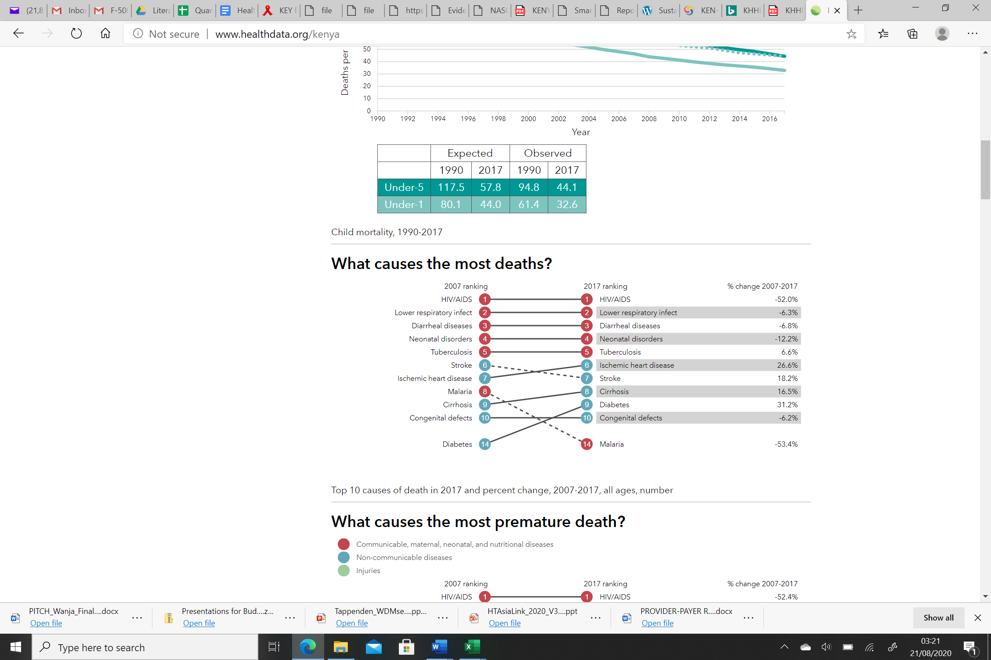

*Source: Adapted from IHME Website*

The new Constitution of 2010 created a devolved system of governance that consists of the National Government and 47 County (sub-national) Governments. Under the new dispensation, health is a devolved function that is shared across the two levels. The responsibility for health service delivery is assigned to the Counties while policy, quality assurance, capacity building and management of national referral hospitals remain the national government’s responsibility as described in the Fourth Schedule of the Constitution of Kenya, 2010.

**Health Financing Reforms in Kenya**

Since independence in 1963, many health financing policy changes have occurred as highlighted in *Annex 1.* In recent years, Kenya has experienced a series of health financing reforms aimed at advancing financial risk protection against different segments of the population. While some of these reforms have indirectly targeted AGYW, for example through EduAfya insurance for all students, none of these reforms have specifically targeted the key populations.

## 2. Methodology

This analysis drew on both primary and secondary sources of information. Secondary data was obtained by conducting a desk review. The team reviewed publicly available government documentation about the health financing systems in Kenya, CSO engagement (locally, regionally and globally) and interventions for KPs, AGYW and Persons Living With HIV/AIDS (PLWH). The data sources included; The Economic Survey 2020, Kenya Health Accounts 2015/16, KDHS 2014, Treasury MTEF Working Group Reports, Auditor General Reports, NASCOP and NACC reports, PEPFAR and Global Fund country reports and other published and gray literature.

Primary data was collected through in-depth interviews (IDIs) with stakeholders within the government health financing space as well as CSO stakeholders involved with KP and AGYW. Specific respondents were purposively selected based on their knowledge and experience in health financing, budget advocacy and KP and AGYW issues. The respondents are as summarized in (Annex 10). Informed consent was obtained before commencement of all IDIs, participation was voluntary and posed no more than minimal risk to the respondents. No personal questions were asked, and no vulnerable populations were involved. Data was collected between July and August 2020.

The key themes on health financing were guided by the health financing functions and intermediate goals as described by WHO i.e. Revenue raising, Pooling, Purchasing, Equity, Accountability and Efficiency (WHO, 2010). The themes on CSO engagement in advocacy were aligned to the Research and Policy in Development (RAPID) framework (Pollard and Court, 2005) as shown below.

**Figure 2: RAPID Framework adapted to CSO Policy Influence**

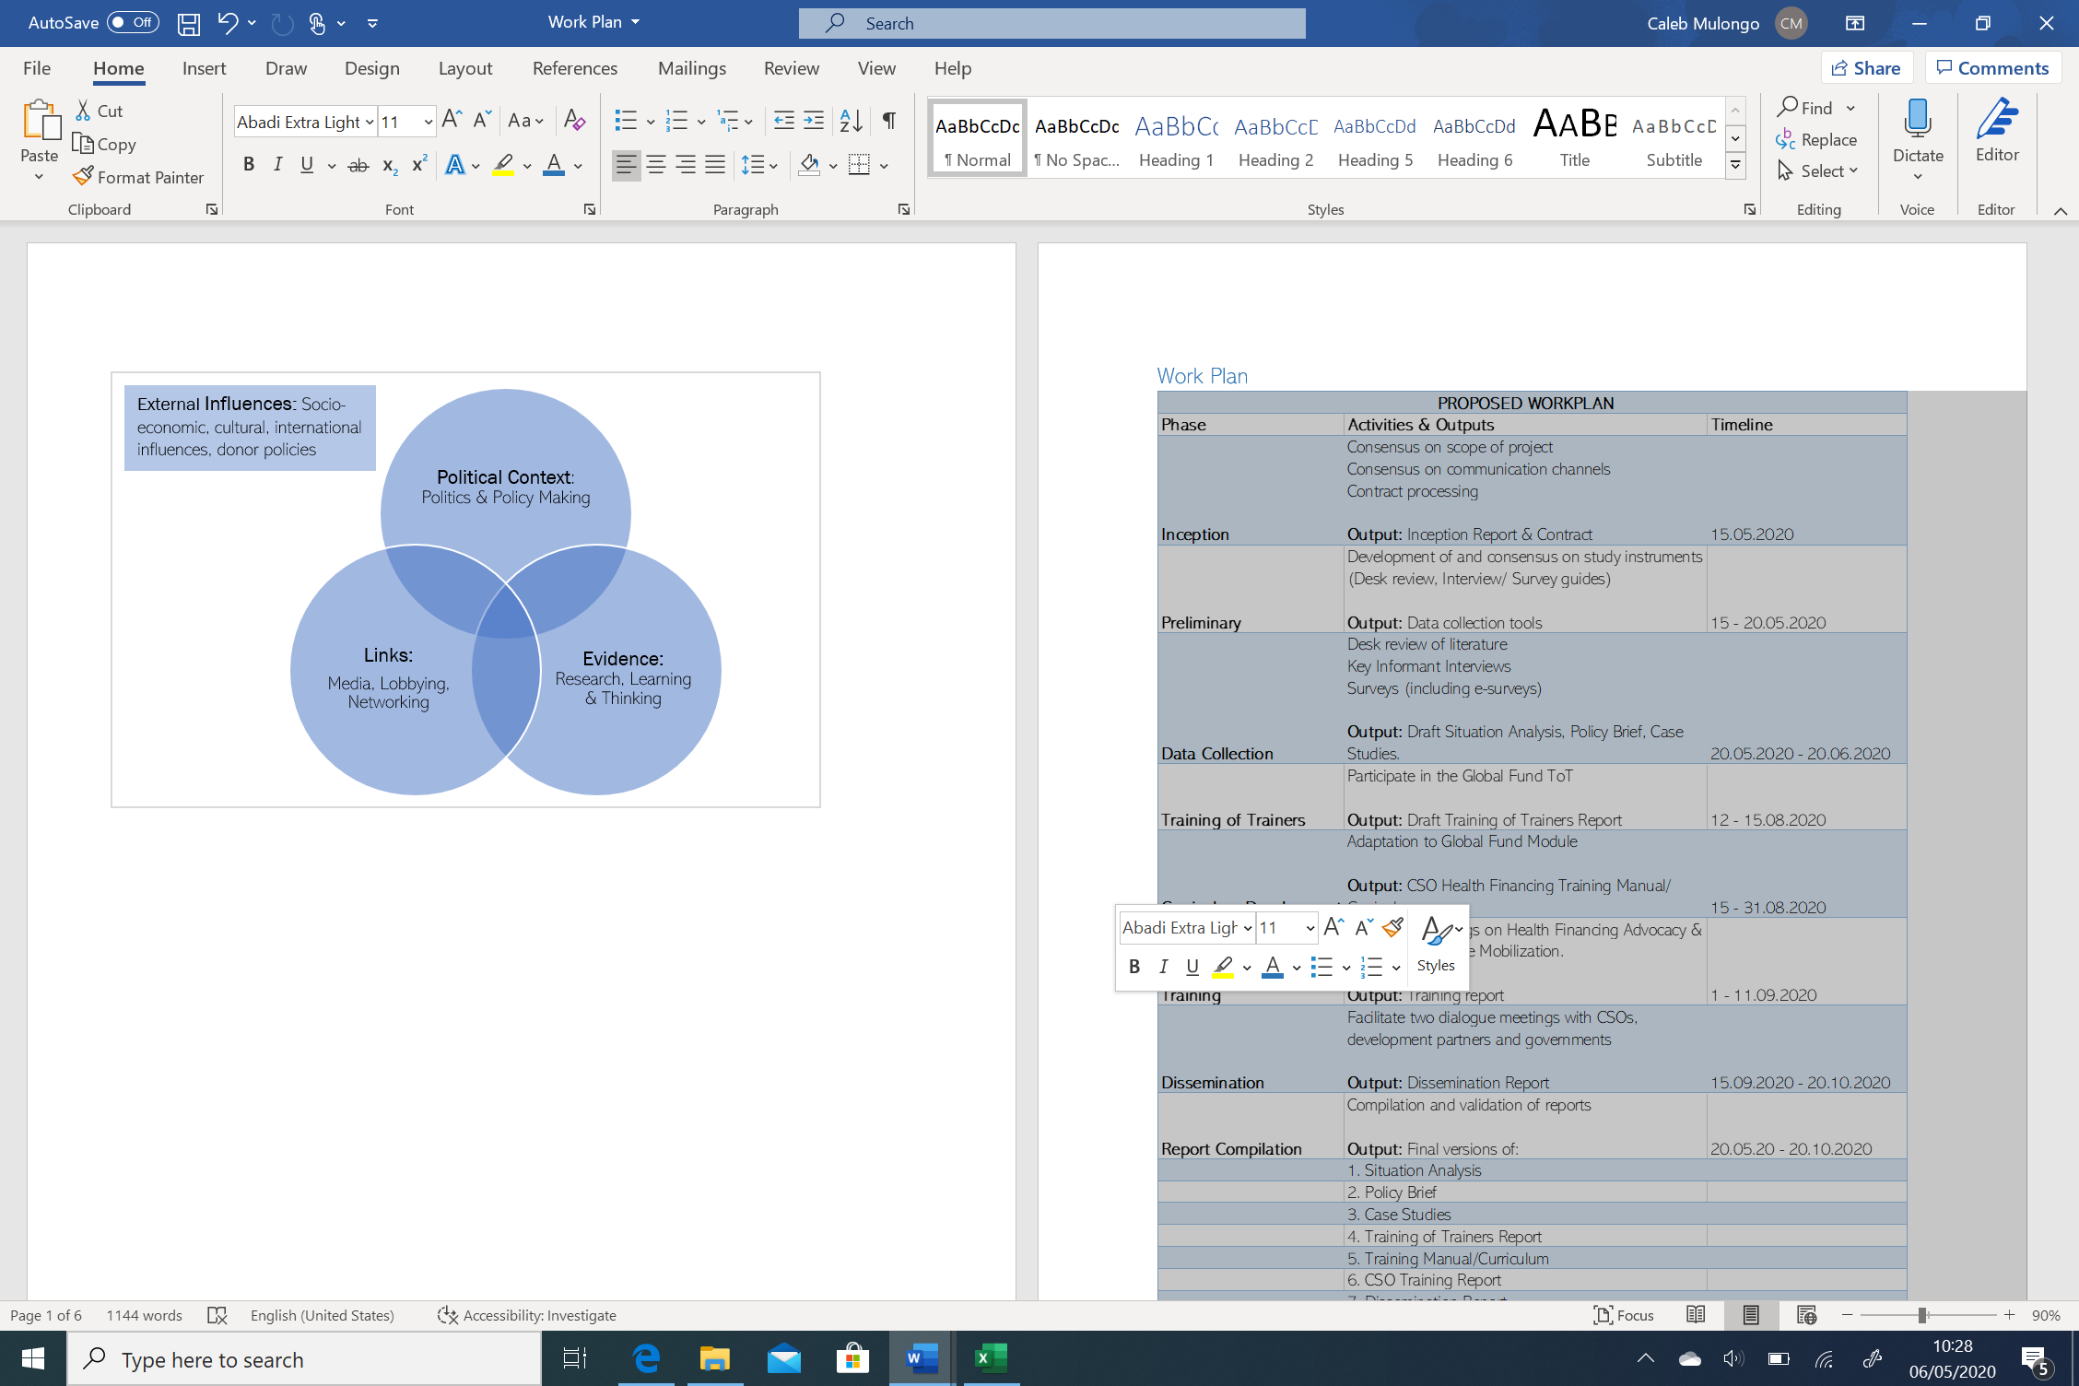

*Source: Pollard and Court, 2005*

Qualitative data analysis was done using thematic framework approach with assistance of NVivo software version 10 (QSR International) to organize and sort the data. De-identification of all study participants was done to ensure anonymity. Quantitative data analysis was done using STATA and Microsoft Excel and presented in the form of figures and tables. Findings have been organized around key themes related to the objectives of the study.

Limitations: The assessment was conducted during the Covid-19 pandemic hence physical meetings were not feasible. The team mitigated against this by leveraging on virtual meetings and telephone calls to draw insights from the key stakeholders. Respondents were based in the Coastal, Nairobi, Kiambu, Nyanza and Western regions and, therefore, may not be reflective of the experience in other regions of Kenya.

## 3. Findings

**Domestic Resource Mobilization for Health in LMICs**

Increasing tax revenues and improved budget prioritization of health have been shown to have the greatest potential in mobilizing more domestic resources for health in LMICs by 78% and 72% respectively. Improved technical efficiency in resource use in health has the potential of mobilizing an additional 26% of resources available for health.

*Source: (Barroy, Sparkes, Dale, & Mathonnat, 2018)*

### 3.1. Macro-Fiscal Characteristics of Kenya

Understanding the trends within the general economic environment and how they influence the resource envelope available to health is essential for effective advocacy for domestic resource mobilisation. These include trends in government revenues, tax administration, government expenditures, public debt and public fiscal balance (difference between revenues and expenditures).

Public debt (external and domestic borrowing) was the leading source of government revenue accounting for between 66% and 80% between FY 2014/15 and FY 2018/19 as depicted in Figure 3.

**Figure 3: Government Revenues between FY 2014/15 and FY 2018/19**

*Source: Economic Survey 2020*

Noteworthy, tax revenues accounted for only 21% to 26% of the government revenues. Whilst the absolute tax revenues progressively increased during the period, they barely exceeded the recommended minimum threshold as a proportion of the GDP (15%) that is deemed adequate to fund basic state functions. It was highest (16.3%) in FY 2014/15 and FY 2015/16, and lowest (15.2%) in FY 2017/18. See figure 4.

**Figure 4: Trends in Tax Revenues in Kenya**

*Source: Economic Survey 2020; Kenya Revenue Authority 2019*

**Advocacy Opportunity in Tax Reforms**

Since tax revenues are known to have the greatest DRM potential, the low tax to GDP ratio in Kenya may signify the need for advocacy for better tax administration with a view to expanding the tax revenues whilst remaining equitable and efficient.

**Figure 5: Trends in the Public Fiscal Balance in Kenya**

Deficit vs GDP Ratio Threshold

*Source: Economic Survey 2020*

As shown in figure 5, the country’s fiscal deficit (expenditures exceeded the revenues) was noted to have tripled in absolute value from KSh.220 Billion in FY 2014/15 to KSh.676 Billion in FY 2018/19. This saw a doubling of the deficit-to-GDP ratio from 3.5% to 6.9% for the same period against the East African Community (EAC) threshold[1] of 3%. The rising fiscal deficit was accompanied by a rising need for debt financing for public expenditure. Consequently, the public debt more than doubled (104%) during the same period, with external debt that is prone to unfavorable interest rates accounting for nearly 60% of the debt. Further, the debt-to-GDP ratio progressively grew from 41.4% to 54.4%, peaking at a level beyond the recommended East African Community threshold of 50% as shown in Figure 6.

**Figure 6: Trends of Domestic and External Debt in Kenya**

*Source: Economic Survey 2020*

**Advocacy Opportunity in Public Debt & Expenditure Management**

The growing fiscal deficit and public debt not only have the potential of reducing the fiscal space for health, but also threaten sustainability of current resource mobilization strategies. These provide an opportunity for advocacy for prudence in public debt and expenditure management in the quest to expand the resources available for heath (fiscal space for health).

### 3.2. Health Financing in Kenya

Health care in many countries is financed through both contributory sources (members directly contribute) and non-contributory sources (members do not directly contribute). Contributory sources are health insurance (social and private) and Out of Pocket payments (OOP), while the non-contributory sources are government, and donor funds (Mwaambi, 2017). Each health financing source has different implications for the overall health care system and advancement towards UHC. The health financing functions namely, revenue raising, pooling and purchasing, are discussed in this report drawing from the Kenyan context.

#### 3.2.1. Revenue Raising in Kenya

The Kenyan health system is funded through three main sources: 1) OOP payments; 2) Government revenues and; 3) Donor funds (Chuma et al 2012).

**Figure 7: Financing sources as a percent of Total Health Expenditure (THE)**

*Source: National Health Accounts (Ministry of Health, 2019)*

##### Out of Pocket Payments (OOP)

OOPs for health refer to spending on health directly by households from their incomes. This excludes any prepayment for health services, for example in the form of taxes or specific insurance premiums or contributions and, where possible, net of any reimbursements to the individual who made the payments. In the financial year 2015/2016, OOP or household payments were the major source of revenue for health in Kenya contributing 39.6% of the Total Health Expenditure (THE) (NHA 2015/16).

Though known to be the least equitable form of financing, is most prevalent in low-income countries, which also have the lowest levels of government financing for health relative to the high-income countries. OOPs do not provide any financial risk protection, lead to catastrophic expenditure and impoverishment as well as provide a significant barrier to access to health care in LMICs.

The restrictive impact of OOPs on health-care utilization is demonstrated by massive increase in the number of patients seeking health care (Maina, 2013) after the recent move by the government to eliminate user fees charged for maternity services and for services at dispensaries and health centres (Leftie, 2013).

**Advocacy Opportunity for Financial Protection**

The predominance of OOP payments as a health financing source in Kenya poses a significant threat of financial hardship for the public especially in light of donor transition.

This presents an advocacy opportunity for financial protection of the vulnerable in society including KPs and AGYWs through government financing of healthcare.

##### b) Tax-based financing

Health care services can be purchased through general government revenue and taxes which include income tax, value added tax, corporate tax, import duties, ear-marked taxes etc. The Kenya Revenue Authority (KRA) is the principal tax-collecting agency in Kenya. According to KRA, in FY 2018/19, income tax was the main form of direct tax (46.7%) and it was charged on a progressive scale. Indirect taxes included value added tax (VAT) accounting for 27.8%, excise duty (13.3%) *inter alia*. Indirect taxes usually tend to be regressive hence an unsuitable source of health financing. There is no government revenue earmarked for health care in Kenya yet (Munge, 2014) despite previous proposals for earmarked funding for health care through a tax on mobile phone airtime (Gathura, 2012) and betting revenues (GOK, 2019).

The government has been increasingly shouldering a greater responsibility in revenue raising as shown in Figure 7. Government spending contributed 37% of THE in 2015/16 (NHA 2015/16). Despite the increasing commitment by the government towards health spending, the health sector remains grossly underfunded (Barasa et al, 2018).

**Figure 8: The government’s public spending on health (GHE) as a % of GDP**

*Source: National Health Accounts 2019; National Treasury; Economic Survey 2020; Office of the Controller of Budget 2019.*

The government’s public spending on health (GHE) as a proportion of the GDP was estimated to be between 1.5% (FY2015/16) and 1.73% (FY2018/19) against the recommended level of 5% required to achieve UHC (McIntyre et al, 2014). See figure 8. This translated to an average GHE per capita of Kshs. 2434 (USD22.5) in FY2015/16 and Kshs. 4841(USD 44.7) in FY2019/20[2]. The GHE per capita remains extremely low compared to the recommended minimum of USD 86 necessary to achieve Universal Health Coverage (McIntyre et al, 2014).

Further, the GHE as a proportion of the total government expenditure, was estimated to range between 5.1% (FY2015/16) and 7.1% (FY2019/20) as shown in Figure 9. These proportions fell significantly below the recommended threshold of 15% as proposed in the Abuja Declaration (WHO, 2001).

## The GHE per capita of USD 22.5 to USD 44.7...remains extremely low compared to the recommended minimum of USD 86 necessary to achieve Universal Health Coverage.

**Figure 9: Trends in GHE to Total Government Expenditure**

OLE-object

*Source: National Health Accounts 2019; National Treasury; Economic Survey 2020; Office of the Controller of Budget 2019.*

**Advocacy Opportunity for Increased Government Allocations to Health**

The low government budget allocation to health below the recommended threshold threatens access to quality health and sustainability of health interventions. This presents an opportunity for advocacy for increased allocations and ring fencing of funds for health by government at both national and county level.

##### c) Donor Funding

Following the country’s reclassification from low income to low middle-income status, there has been a steady decline of donor funding (World Bank Group, 2015; MOH, 2019). The donor funding which stood at 31% in 2005/2006 had decreased to 23.4% by 2015/16 (NHA 2015/16) as shown in figure 7. Donor funding provides general budgetary support and supports specific programmes such as HIV/AIDS, Malaria, and Tuberculosis programmes. Donor funding is usually channeled through the central government (on-budget development partner support) or directly managed by the development partners or their agencies (off-budget development partner’s support).

**Revenue Raising for KP and AGYW Programs**

Donor funding has been significant in supporting implementation of comprehensive HIV programs to reduce HIV burden among KPs. External funding accounted for 73% of HIV spending in 2012/13; 60% between 2018 and 2020 (Chaitkin et al, 2017); and 91.3% for FY20/21 (76.8% PEPFAR, 14.5% GF) (PEPFAR, 2020). Funds for HIV prevention among KPs and AGYW were noted to come from three main sources: PEPFAR, Global Fund, and domestic funds.

PEPFAR plays the predominant role in HIV funding in Kenya accounting for 86% of the donor funding for HIV between 2018 and 2020 (Kenya Coordinating Mechanism, 2017; Chaitkin et al, 2017). Other sources include: The Bill and Melinda Gates Foundation, UHAI, Viiv Healthcare, Mama Kash, Gilead Sciences *inter alia*.

Efficiency in financing KP and AGYW interventions is hampered by the lack of integration of financing sources as well as implementation across the national and county governments, and across the public and private health sectors (Chaitkin et al, 2017).

“There is a lot of fragmentation in the funding, data management and implementation of KP and AGYW programs in the country. This cuts across the MOH, Counties and the private facilities.” – Implementing Partner

Noteworthy, in FY 2015/16, the Government did not fund any programs targeted at KPs and other priority populations, hence these were exclusively funded externally (PEPFAR, 2017; Chaitkin et al, 2017).

**Advocacy Opportunity for Increased Government Funding for KP and AGYW Programs**

The significant reliance on donors for financing and implementation of HIV, KP and AGYW programs compromises the sustainability of the interventions (McIntyre, 2018). This provides an opportunity for; a) budget advocacy for increased government funding and ownership of HIV, KP and AGYW interventions; and b) advocacy for capacity development for HIV, KP and AGYW program implementation amongst in-country partners and teams.

County own-source revenue has been cited as a promising approach to domestic resource mobilization in the advent of donor transition. However, insufficient and fragmented data on HIV, KP and AGYW programs between the national, county governments and other stakeholders has made it challenging for counties to identify existing opportunities and capacity for meaningful own-source revenue generation, and what role these resources could play in sustaining HIV interventions. Understanding the needs and potential of each county will therefore be required.

**Advocacy Opportunity for Integration KP and AGYW Programs**

The fragmentation in financing and implementation of HIV, KP and AGYW programs across governments (national and county) and sectors (private and public) threatens efficiency and sustainability of these services. This provides an opportunity for advocacy for inclusion of target interventions for KPs and AGYW within the health system across the levels of government and the sectors to reduce fragmentation.

Insufficient and fragmented data on HIV, KP and AGYW programs in the country limits the capacity for effective resource mobilisation, policy advocacy as well as decision making. This provides an opportunity for advocacy for better data management, data integration and knowledge management at all levels.

#### 3.2.2. Revenue Allocation

In Kenya, the Commission on Revenue Allocation (CRA) was set up in 2010 under Article 215 of the Constitution with the mandate to recommend the basis for equitable sharing of revenues raised nationally between the national and county governments and among the county governments. Additionally, the commission is tasked with encouraging fiscal responsibility, review of parliamentary bills relating to the equalization fund and revenue sharing for both the national and county governments.

Articles 201 to 203 of the Constitution of Kenya also focus on the equitable sharing of finances in the country (*Kenyan Constitution, Chapter Twelve, Part 1, Article 201 to 203*, n.d.). Article 201 stipulates the principles of public finance. It provides for a fair society promoted by the public finance system. This results from, among other factors, the vertical sharing of revenue raised nationally in Kenya. The

constitution asserts that a minimum of 15% of the national revenue should be allocated to the counties and 0.5% as an equalization fund (*The Vertical Process of Sharing National Revenue in Kenya*, n.d.). Figure 11 depicts the flow of resources through the health system.

**Figure 11: National and County-level flow of health funds in Kenya**

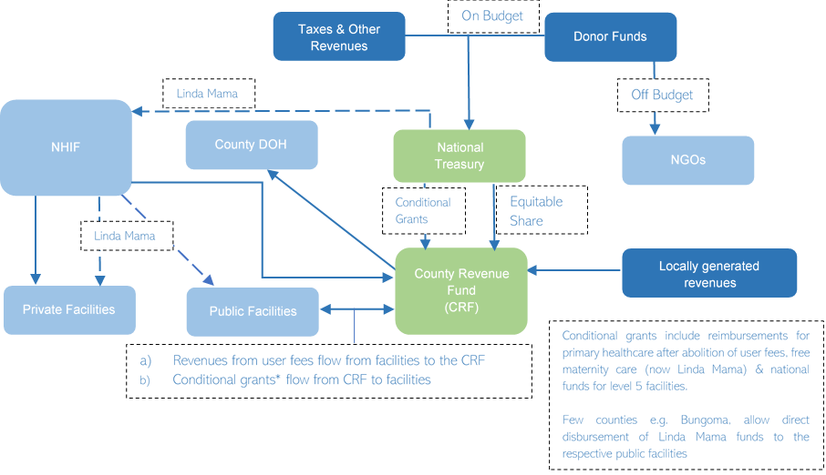

*Source: Adapted from Dutta et al., 2018*

The county governments receive conditional grants from the national government’s equitable share. That is, after both levels of government receive their share of the revenue raised nationally, the county governments receive additional funding from the national government’s share.

Once the division of revenue is carried out, the Senate determines how much each of the 47 counties should get from the county’s share of the national income. This is referred to as horizontal sharing. The County Allocation of Revenue Bill under Article 218(1) (b) facilitates the allocation of revenue to counties in Kenya on the basis determined through the revenue sharing formula (Article 217).

The formula is designed to enhance service delivery, promote balanced development, and incentivize fiscal effort and prudence across the counties as shown in Annex 3. For the first time since the adoption of the new constitution, the revenue sharing formula (3rd basis) incorporates health as a key determinant with a weight of 17%.

Except for a few counties like Makueni, West Pokot and Samburu, majority of public facilities across the counties are by law required to remit revenues they generate from service delivery (including Linda Mama) to the County Revenue Fund (CRF). This limits the facilities’ access to the funds as well as the autonomy in utilization of the revenue.

Revenue Allocation

The Cabinet Secretary for National Treasury and Planning should prepare and table the revenue allocation bill at least two months before the end of the financial year (30th June). The bill is tabled on February 15th of each year. Once the Senate approves the bill, it becomes the County Allocation of Revenue Act.

This officially determines how much of the county equitable share each county should get based on the revenue sharing formula. Each county’s equal share of revenue (except some conditional grants) is then remitted to the respective [County Revenue Fund](https://www.afrocave.com/county-revenue-fund-kenya/) (CRF) account.

Revenue Allocation for KP and AGYW Programs from the NHA 2015/16, HIV/AIDS took the largest share of resources for disease allocations, at 18.7% and 20.1% in FY 2012/13 and FY 2015/16, respectively. Figure 12 highlights the resource allocations to respective disease categories between FY 2012/13 and FY 2015/16.

**Figure 12: Distribution of THE by Disease/Condition, FY 2012/13 and FY 2015/16**

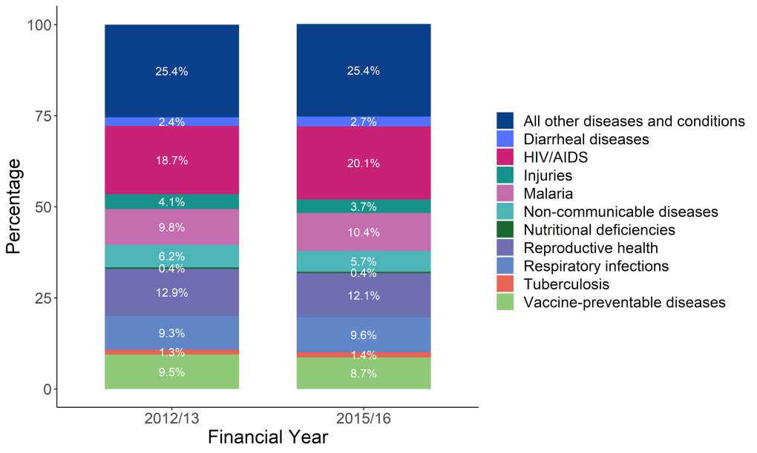

*Source: National Health Accounts 2015/16*

Most of the funding for KPs and AGYW specific interventions is off-budget[3] by donors through implementing partners. For instance, between 2018 and 2020, the off- budget financing by the Global Fund was as follows: 71% for PWID; 92% for MSM; 100% for FSW; and 91% for Adolescents and Youth as shown in Figure 13.

**Figure 13: On- versus Off-budget composition of proposed Global Fund investment in HIV for 2018–2020**

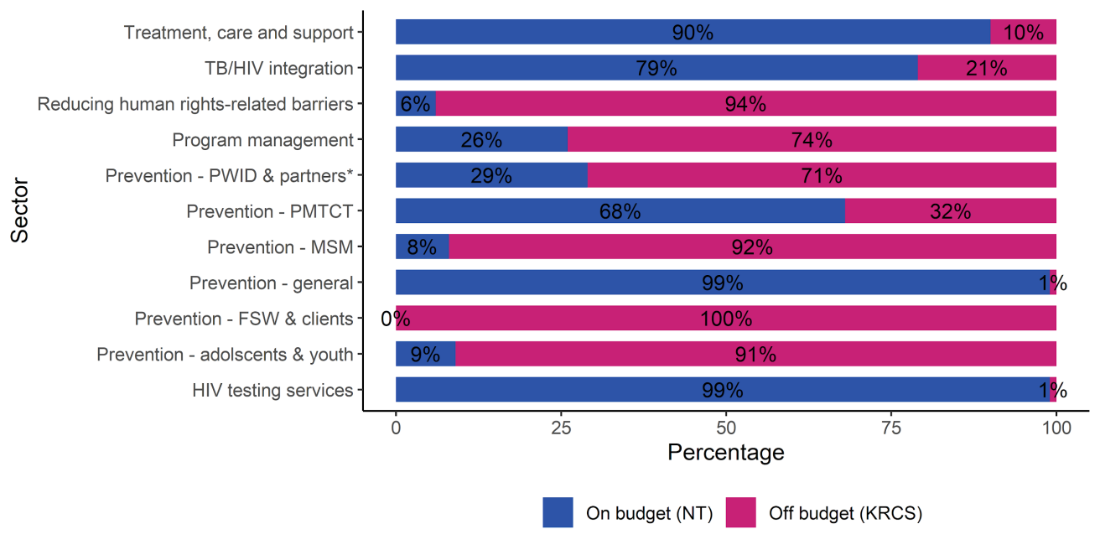

*Source: Chaitkin et al, 2017*

**Successes in CSO Advocacy for the funding of KPs by Global Fund in Kenya**

KP constituents and AGYW groups only started engaging in GF grants recently. Previously, GF grants were primarily focused on government and networks of people living with HIV. Through dedicated advocacy, funds previously allocated to PMTCT were increased up to USD 52 Million. This success illuminated the potential CSOs have in influencing country specific funding trends within the Global Fund. Consequently, KP-led advocacy in the last grant led to the Kenya grant being highlighted as the most KP friendly grant issued by the Global Fund in 2017-2019.

Through articulation of issues facing KP by persons who fully understand them, there has been increased accountability within the Global Fund KP allocations. This has led to KP groups being directly funded to implement KP programs. The key messaging for the KP and Priority Population representatives was “communities are the experts in their own programming”. This led to a significant increase in funding for the MSM led programs to implement Global Fund interventions.

The bulk of the donor funding for HIV that is channeled through government and government agencies (Figure 14) was noted to have been allocated to general prevention and PMTCT measures; treatment, care and support; HIV testing; and HIV/TB integration as shown in Figure 13.

**Figure 14: Resource Allocation for HIV Funding by Global Fund to various entities 2018-2020**

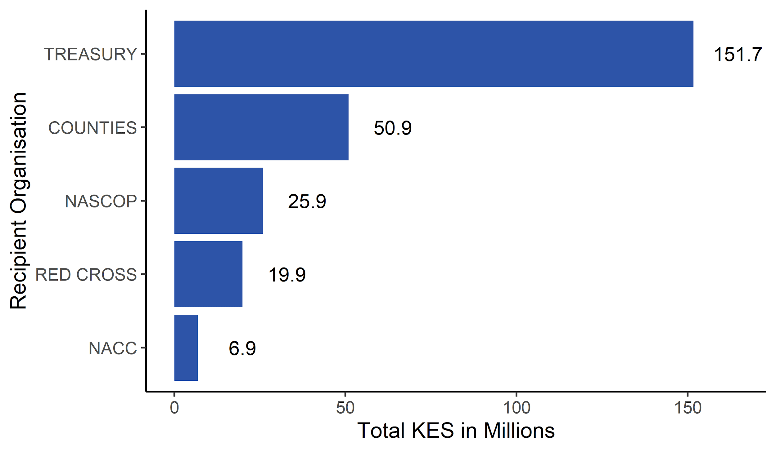

*Source: NASCOP, 2020*

**Advocacy Opportunity for More On-Budget Financing**

The significant off-budget financing of KP and AGYWs limits the visibility and prioritization and ownership of these key groups within government. Further, this threatens integration and sustainability of the interventions within the health system. It is commendable that the donor community had prioritized and instituted phased integration and transition of HIV care services to local public and private partners and systems (USAID, 2020).

This provides an opportunity for continued advocacy for integration of funding and implementation of KP and AGYW programs within the health system at both National and County Government levels.

##### 3.2.2.1 Budgeting process

In Kenya, the budgeting process is designed to align to attainment of the long-term national goals outlined in the Vision 2030. In the medium term, the budgets align to the Medium-Term Expenditure Framework (MTEF) that guides public expenditure over a 3-year span. To ensure that public expenditure efficiently contributes to the national policies, the PFM Act 2012 (Section 25) anchors the annual budgeting to the MTEF while adopting a performance-based approach.

**Misalignment between Budgeting and Planning for Health in Kenya**

The budgeting and planning for health in Kenya were noted to be misaligned due to weak systems, poor stewardship, unreliable data and poor stakeholder participation. The misalignment persisted even after the adoption of MTEF as a planning tool.

Source: (Tsofa, Molyneux, & Goodman, 2016; Le Houerou & Taliercio, 2002)

**a)** **Medium Term Expenditure Framework (MTEF)**

The MTEF is a transparent planning and budget formulation process within which the Cabinet and central agencies establish credible contracts for allocating public resources to their strategic priorities while ensuring overall fiscal discipline. The process entails two main objectives: the first aims at setting fiscal targets, the second aims at allocating resources to strategic priorities within these targets. In implementing the MTEF in Kenya, ministries, departments and state agencies are required to focus on the expected outcomes of their expenditures and programmes. The annual budget and the (3-year) rolling MTEF inherently provides a way to evaluate the realization of the outputs and outcomes and their contribution to the overall economic growth of the economy (GOK, 2020). Annex 4 shows an MTEF aligned FY2021/22 budget calendar.

The MTEF also encourages political buy-in by ensuring consistent cabinet briefing and approval at all stages of the budgeting process alongside significant stakeholder engagement.

“The annual budget and the (3-year) rolling MTEF inherently provides a way to evaluate the realization of the outputs and outcomes and their contribution to the overall economic growth of the economy.” – The National Treasury

**Figure 15: MTEF Flow Summary**

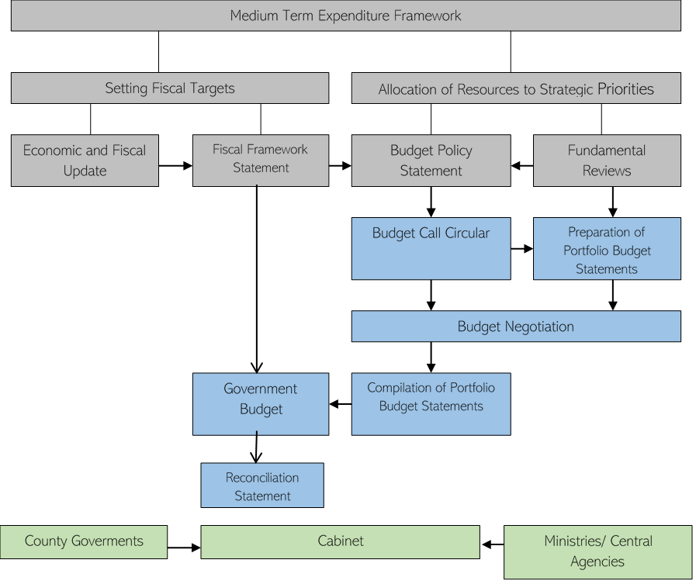

*Source: Adapted from the World Bank,1998*

1. Program Based Budgeting (PBB)

PBB is a governance tool aimed at improving efficiency and effectiveness of public expenditure by linking the funding of public sector organizations to the results they deliver, while tracking performance for decision making (IMF, 2009). PBB as an approach ensures that resource allocation and utilization are aligned to specific policy objectives rather than based out previous spending trends. Resultant budgets for each economic sector are organized along programs and subprograms that contribute towards attaining the desired policy objective. Further, the programs and subprograms have specific targets and indicators. (IMF, 2009; IBP, 2015)

In Kenya, the PFM Act of 2012 (Section 25 & 35) provides for a transition in the budgeting approach from the traditional input-based line item budgeting, which gives little emphasis on policy objectives and outcomes and does not provide adequate information for fiscal policy decision making, to program-based budgeting approach. As a result, the country had its first PBB in FY 2012/13. The subsequent budgets saw significant refinements embracing more policy alignment, clarity, predictability, transparency and accountability (IBP, 2015; OECD, 2014).

The PFM Act 2012 outlines the budget process for the National Government (Section 35-45) and the County Government (Section 117- 137). The process evolves through four major stages, i.e. formulation, approval, implementation, and evaluation (Githinji, 2020) discussed below. The progression, which is largely synchronized at both County and National levels, is outlined in Annex 6,7 and 8.

**Advocacy for Strengthening of Program Based Budgeting in Kenya**

PBB has not yet been implemented in a way that sufficiently monitors actual spending of retained line-item allocations against programmatic objectives. The National Treasury continues to rely on historical allocations to traditional line-items with marginal adjustments year-over-year. Budgeting in this way fails to ensure that funding is matched to program priorities. Successful PBB requires adequate systems and processes to link accounting to program implementation—such systems have not yet been deployed.

*Source: (NACC, 2018)*

1. **Budget Formulation (Prioritization and Budget Estimates)**

This stage includes; i) integrated planning process consisting of both long-term and medium-term planning; ii) planning and determining financial and economic policies and priorities over the medium term; iii) preparing overall estimates in the form of the Budget Policy Statement of national; iv) government revenues and expenditures, and general estimations in the form of the County Fiscal Strategy Paper (CFSP) for the county governments and v) preparing the budget estimates. The executive arm of the government is in control of the formulation stage.

In principle, the MoH/ CDOH’s role in the process of budget formulation boils down to three key inputs; a) Analysis of expenditure forecasts against expected revenues; the aim here is to estimate the potential for increased health spending. Institutionalizing fiscal space for health analysis within the Ministry of Health will be an essential step in this direction; b) Drafting of credible, well-defined health budget proposals. This requires systematizing costing and priority-setting exercises within the defined envelope; c) Engaging in budget negotiations and advocating for a sound health budget allocation (*All the Key Stages in the Budget Process in Kenya*, n.d.).

This stage of the budget cycle (prioritization and determination of resources available for the upcoming year) begins with the release of the budget circular on 30 August of the current financial year. The process takes place over a six-month period between 30 August and 28 February. During this period, the health sector reviews the performance of the previous financial year and determines and costs strategic priorities for the upcoming financial year.

Preparation of budget estimates begins after the provisional budget ceilings are established through the Budget Review and Outlook Paper. The MOH and DOH prepare a budget proposal for health investments, outlining the plan for using health resources and the actual funding needed to realize health sector commitments, regardless of the provisional ceilings set (Health Policy Project, 2016).

**ii.** **Budget Approval**

During this stage, annual estimates of public revenues and expenditure made by governments acquire a status of legal action after discussion and voting in parliaments (the parliament and the 47 county assemblies). Budget approval involves parliament adopting the Budget Policy Statement and the County Assemblies adopting their respective CFSP as a basis for future deliberations; amending and approving the budget estimates after the national or county executive (specifically the Treasury) tables them before Parliament or the County Assembly, and enacting the Appropriation Bill and any other Bills required to implement the budgetary proposals. The budget approval stage runs from 30 April to 30 June.

**Iii.** **Budget Execution**

At this stage, the Executive implements the budget proposals passed by Parliament or the County Assemblies at the approval stage. Parliamentary oversight also takes place at this stage. It involves; evaluating and accounting for the national and county governments’ budgeted revenues and expenditures; and reviewing and reporting on those estimated revenues and expenses every three months.

The approval of the Appropriation Bill marks the beginning of the budget execution period, which runs from 1 July to 30 June of the following calendar year. The MOH and CDOHs can request additional funding during the supplementary budget planning (i.e., within the first two months of the FY and are due between October and November) (Health Policy Project, 2016).

The MOH’s role in health budget execution is fundamental as it enables the actual implementation of National Health Policies Strategies and Plans (NHPSP) activities. The Ministry supervises, supports, and oversees budget execution because it is often the deciding factor for the extent of implementation. Inadequate technical and administrative support and oversight capacity generally result in a low health budget execution rate. Evidence shows that monetary space expansion for the health sector is mostly possible by merely increasing effectiveness in government health spending (Barasa et al., 2017).

**Figure 16: Trends in MOH Budget Absorption between FY14/15 and FY 19/20**

*Source: MOH MTEF Sector Working Group Reports, 2018 and 2019; National Treasury Budget Review and Outlook Paper, 2020.*

**Advocacy Opportunity for Efficiency in Resource Utilization.**

There has been a steady rise in the absorption of MOH budgets post devolution peaking at an average of 91.6% in FY2019/20 as depicted in Figure 16. Whilst the high absorption rates ensure availability of resources for health, they must be coupled to efficiency and accountability systems to ensure more health for available resources (maximize value for money).

**iv.** **Budget Evaluation/ Audit**

During the budget execution period, the MOH and CDOH will monitor the spending of respective appropriated funds with the aim of promoting efficiency, preventing wastage and fraud, and ensuring high-performance in-service delivery. State departments and counties are required to comply with the legal requirements for accounting and reporting on the appropriated funds in the implementation period (PFM Act, 2012; Health Policy Project, 2016). This is usually the last stage of the budget process, where the Office of the Auditor-General (OAG) audits and reports on the accounts of both the national and the county governments within six months of the end of the FY. The Budget Review and Outlook Paper (BROP and CBROP) are the basis for the evaluation (All the Key Stages in the Budget Process in Kenya, n.d.)

**Advocacy Opportunity for Accountability**

Only 22% of all the financial statements for government expenditures between FY 2012/13 and FY 2016/17 were fully compliant to the financial management standards (Unqualified audit opinion).

This provides an advocacy opportunity for strengthened PFM and accountability systems within government.

**Table 1: Analysis of Audit Opinions on Government Expenditures between FY 2012/13 and FY 2016/17**

|  |  |  |
| --- | --- | --- |
| **Audit Opinion** | **Total FS** | **Average %** |
|
| Unqualified | 170 | 22 |
| Qualified | 383 | 48 |
| Adverse | 106 | 13 |
| Disclaimer | 131 | 17 |
| **Total** | **790** | **100** |

**Challenges to Effective Budgeting and Advocacy for KP and AGYW Programs.**

1. Lack of information and knowledge on the legislative and budgeting process as well as specific timelines by various stakeholders i.e., CSOs, KPs and AGYWs.
2. Criminalization of KPs.
3. Undefined roles and responsibilities and information asymmetry between levels of government and the public and private sectors; siloed planning.

Several counties in Kenya have implemented Program Based Budgeting (PBB) - 12 counties[4] - which saw increased allocations to their collective health sectors by Kshs 1.2 billion from the previous fiscal year (FY) 2015/16 budget (Health Policy Plus, 2016). Additionally, by including HIV as a distinct sub-program in their annual budgets, each of the counties collectively allocated Kshs 186 million to HIV for FY 2016/17. In the previous year, only four of the 12 counties included HIV programs in their budgets.

PEPFAR too adopted Program Based Incremental Budgeting for its Country Operational Plans (COP19 and COP20) with a view to aligning funding to intended outputs and outcomes.

Over 80% of the community-based organization representatives interviewed had not at any point interacted with **regulations governing fundraising and accountability for CSOs.**

They were further not aware of the available avenues to engage in budget advocacy for their communities. This raises a critical question on how exactly these organizations structure their fundraising efforts and agendas. The level of knowledge on the responsibility and entitlements in the national budget is generally low with most feeling they did not bear any control whatsoever in what national budgets cater for.

There are no specific formal processes allowing KP communities to be engaged in the budget processes, except during public participation. However, with the dawn of UHC and Kenya committing to implement this, there is need for dedicated engagement processes on how Key and Priority populations can engage in the design and budgeting for their programs.

Community health bill provides guidelines on how to incorporate how CSOs engage in the health system and ideally supplements the NASCOP guidelines on how CSOs engage with community health systems. This still creates a challenge since there is no recognition of the KP health workers as CHWs. There still exists no documented or formalized health financing policy or document outlining how KP programs should be financed.

“Most KPs and AGYWs do not engage in the budgeting process because they do not understand the budget cycle and feel that the process is too technical for the lay persons to understand.” - KP Representative

“… such a document [a health financing policy for KP], becomes difficult to implement mainly because of criminalization of KP. Countries have tied themselves in laws that make it difficult to plan for what they can do for KP.” - *KP Representative*

Sharing and adopting some of the lessons from the KP program learnt over the years will move CSO capacity to more effectively engage in the processes. They can benefit from knowledge and information on how, who and when to engage in the processes.

Challenges with cash flow and timely disbursement of funds at the county level was cited as a major cause for concern for HIV programs in donor transition. Budget execution for procurement continues to be hindered by a series of bureaucratic delays related to giving specifications for goods to be bought, nominations to tender- evaluation committees, and disbursing funds from National Treasury.

“Stockouts of commodities for KPs such as lubricants, HIV testing Kits, medicines for sexually transmitted infections and masks at service delivery points is not uncommon due to delays in disbursement of funds”. – *County AIDS and STIs Coordinator (CASCO)*

Undefined roles and responsibilities and information asymmetry between levels of government and the public and private sectors and siloed planning has also led to duplication of efforts creating major inefficiencies.

“At times, we (county governments) don’t even know what activities the ministry of health is doing. You can even find instances where the governor is not aware of what some development partners are doing in the county. It is that bad. We need to co-ordinate and work together so that we get to know where and how resources for HIV are allocated.” – *County Health Official*

Lack of information on the legislative and budgeting process as well as specific timelines by various stakeholders i.e. CSOs, KPs and AGYWs was cited as a major hindrance to participation in the budgeting process. Time for budget negotiations was cited as being short, and budget sessions are not long enough to make the process as participatory and useful as it should be.

“Most times, the call for citizen participation is short and hence most people don’t participate in the budgeting process. We sometimes are not aware when these meetings are supposed to take place.” *(Healthcare Provider)*

Unavailability of complete, timely, quality data was also cited as a major challenge to structuring of budgets accurately according to needs for priority populations, programs, and services.

“Compilation of data needed to support strategic, data-informed purchasing of services also becomes a huge challenge when there are no integrated information systems for all actors involved.” – *County Director of Health*

#### 3.2.3. Pooling Mechanisms in Kenya

Revenue Pooling is a core function of health financing policy that encompasses spreading of financial risk across a population or group in the population through the accumulation of pre-paid health care revenue (Carrin et al., 2007). This is to ensure no individual carries the full burden of paying for health care and promotes equity and financial protection to households. It encompasses the insurance function within a health system (implicit pooling) as well as general tax revenue (explicit pooling) (Chuma & Okungu, 2011). These pooled funds are then used to pay for all or part of the cost of providing a defined set of health services for members of the pool. Figure 16 shows the trends in health insurance coverage in Kenya between 2009 and 2014.

**Figure 17: Health Insurance Coverage in Kenya between 2009 and 2014**

*Source: Kazungu et al, 2017*

Health insurance coverage was highest amongst the richest income quintile (42%) compared to the poorest income quintile (3%). It was also higher among the urban population (27%) than the rural population (12%).

**a) The National Hospital Insurance Fund (NHIF)- Social Health Insurance**

NHIF was established in 1966 with mandatory membership for all employed Kenyans. NHIF is the primary provider of health insurance in Kenya, with a mandate to enable Kenyans to access quality and affordable health services. NHIF is positioning itself as a key player in the attainment of universal healthcare in the country. NHIF covers all individuals working in the formal sector and their dependents aged below 21 years. Children aged 21 years and above who are still in school are entitled to benefits from their parents’ memberships, and people in informal sectors can join voluntarily.

About 88.4% of households with health insurance are covered through the NHIF, contributing about 5% of THE in FY 2012/13 (KHHUES, 2013).

“By 2017, NHIF was estimated to cover about 20% of the Kenyan population and 89.4% of the households with health insurance.” – Dutta et al, 2018

**KP and AGYW Services Covered by NHIF**

Reproductive Health: Family Planning, Antenatal Care (ANC), Maternity and Post Natal Care (PNC) up to 6 weeks after delivery and PMTCT. (Linda Mama, Edu Afya, Civil Servants & Supa Cover).

Rehabilitation for drugs and substance abuse. (Edu Afya, Civil Servants & Supa Cover Scheme).

**Figure 18: NHIF Performance between FY 2014/15 and FY 2016/17**

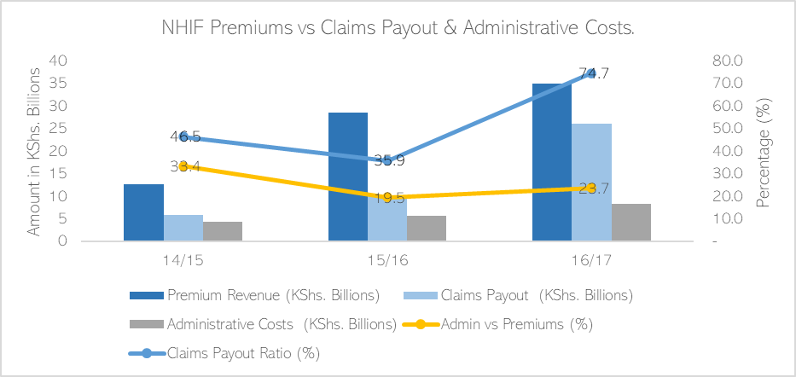

*Source: Treasury Health Sector Report 2016/17; Auditor General NHIF audit report 2014/15, 2015/16.*

As depicted in Figure 18, the premium revenues nearly tripled while claims paid out more than quadrupled between FY 2014/15 and FY 2016/17. The claims paid out as a proportion of the premiums earned (claims payout ratio) between FY 2014/15 and FY 2015/16 (46.5% & 35.9% respectively) were below the internationally acceptable threshold of 50-70%. Further, the administrative costs as a proportion of the premiums earned were consistently high (33.4%, 19.5% and 23.7% respectively); levels higher than the acceptable threshold of 5-7% for public health insurance systems (Carrin & James, 2005).

**Advocacy Opportunity for Efficiency in NHIF.**

The low claims-payout ratio below the 50% threshold may imply limited value afforded to the policy holders hence an opportunity for continued advocacy for increased payouts for patient care by NHIF.

The persistently high administrative costs above the 5-7% threshold may imply administrative inefficiencies within the national health insurance agency hence an opportunity for advocacy for more accountability and business process improvements within NHIF.

**b) Private Insurance**

In Kenya, there were 31 private health insurance providers registered by the Insurance Regulatory Authority in Kenya in 2018 (IRA, 2019). Private insurance accounted for 2-4% (Health Financing Project, 2016; Barasa Edwine, Rogo Khama, Mwaura Njeri, Chuma Jane, 2016). Contributions to private health insurance are mostly non-regulated with different companies charging different rates based on their risk assessment. These rates are unlikely to be progressive.

“For individuals, private health insurance firms often …. fail to cover people with chronic conditions or when they do, the premiums are unaffordable, the result being poorer households opting for more basic and, hence, cheaper packages.” – *Okech, 2014*

**Figure 19: 5yr Financial Performance of Private Health Insurance in Kenya**

Claims Ratio Upper Limit (70 %)

*Source: Insurance Regulatory Authority, 2019*

There has been a steady rise in spending on private health insurance in Kenya between 2014 and 2018 with an increase in both the premiums collected and medical claims incurred by private medical insurers as shown in Figure 19. The claims-payout ratio for private medical insurance has remained significantly high over the five-year period. Additionally, the medical insurance sector recorded significant losses over the five-year period.

**c) Community Based Health Insurance Schemes (CBHIS)**

CBHIS have been in operation mainly in rural and informal populations in Kenya. Their operations have however, been limited in nature and differ significantly from one scheme to another (Okech, 2014).

With financial support from the German government, the Ministry of Health implemented the Output Based Approach (OBA) voucher project since the year 2006. The project was aimed at providing subsidized vouchers to poor populations in the counties of Kisumu, Kilifi, Kiambu, Kitui and Nairobi’s informal settlements of Korogocho and Viwandani to access health care and maternal care services at designated facilities (Ministry of Health, 2016). There is no policy governing the operations of CBHIs in Kenya in terms of operation, quality and benefit package (Okech, 2014).

**d) Tax Based Financing**

Universal Health Coverage as envisioned by the current government of Kenya, has adopted this model as a way of financing access to healthcare in Kenya.

“Increased government spending through tax-based financing and social health insurance (SHI) have played a dominant role in most countries which have advanced greatly towards achieving UHC.” - Oxfam, 2013

**Pooling Mechanisms for AGYW and KP Services**

Currently, neither the NHIF nor private health insurance schemes provide HIV/AIDS, or KP specific cover except for opportunistic infections, rehabilitation and reproductive health services which are within the general terms. Noteworthy, HIV treatment remains a major exclusion for most insurance providers.

The Kenya AIDS Strategic Framework 2014/15-2018/19 envisioned the establishment of a separate HIV Trust/ Investment Fund, housed under the National AIDS Control Council (NACC), to implement innovative financing mechanisms to draw new resources that would be ring-fenced for high priority areas, interventions and underfunded areas. The fund would subsidize Government liability in HIV investment and Prevention costs hence facilitate Kenya’s drive towards Universal Health Coverage (MOH, 2014). This fund is yet to be operationalized.

“…. only 14.6% of women between ages 15–49 years had health insurance by 2014.” - KDHS, 2014

**Advocacy Opportunity for Effective Pooling for KPs and AGYW**

The delay in operationalization of the HIV Investment Fund may present an opportunity for advocacy for its implementation and integration of the fund within the UHC agenda rather than independent implementation. Integration would ensure maximization of efficiencies of pool consolidation rather than fragmentation.

The low insurance coverage in general, and specifically amongst the poor, rural communities and women aged between 15 and 45 years, provides an opportunity for advocacy for aggressive and targeted NHIF recruitment.

#### 3.2.4. Purchasing Arrangements in Kenya

Purchasing of healthcare in Kenya is predominantly centralized through Kenya Medical Supplies Authority (KEMSA) for the public sector and Missions for Essential Drugs (MEDS) for the Faith Based providers. Private sector providers have separate purchasing arrangements mainly with private suppliers. Additionally, purchasing of health in Kenya is done through contract and integrated models of purchasing. Under the contract model, the National Hospital Insurance Fund purchases (NHIF) out-sources services from public and private healthcare facilities that it contracts (public contract). Private health insurers (including community‐based health insurers and micro–health insurers) purchase healthcare services from public and private providers (private contract). Under the integrated model, the MOH purchases services from public tertiary hospitals that it owns while the County Departments of Health (CDOH) purchase services from public secondary care hospitals and primary health care facilities that they own (Mbau et al., 2018; Obadha et al., 2019).

Predominant purchasing mechanisms in health services in Kenya include fee for service (FFS), bundled payments (by households, insurance companies, government, private enterprises), capitation (through insurance), line item, programme-based and global budgets (government). The county governments are the main purchasers of health services. Annex 7 provides a summary of purchasing mechanisms actively practiced in Kenya.

**Advocacy Opportunity for Strategic Purchasing of Health Services**

Fee-For-Service as a reimbursement mechanism neither incentivizes quality of care nor cost control, but makes care costly. Its predominance in the purchasing of care in Kenya indicates an advocacy opportunity for reforms to align reimbursement mechanisms to strategic purchasing.

The Kenya Essential Package for Health (KEPH) provides “a set of health services that should ideally be accessible to all Kenyans as a matter of entitlement” (Ministry of Health 2016a). The package includes prevention, screening, detection, and management of various diseases and conditions including HIV. In line with the progress towards UHC in Kenya, the government in 2018 prepared the UHC Essential Benefits Package outlining services covered during the pilot phase.

**Figure 20: Purchased services by health function in Kenya were predominantly curative outpatient and inpatient services.**

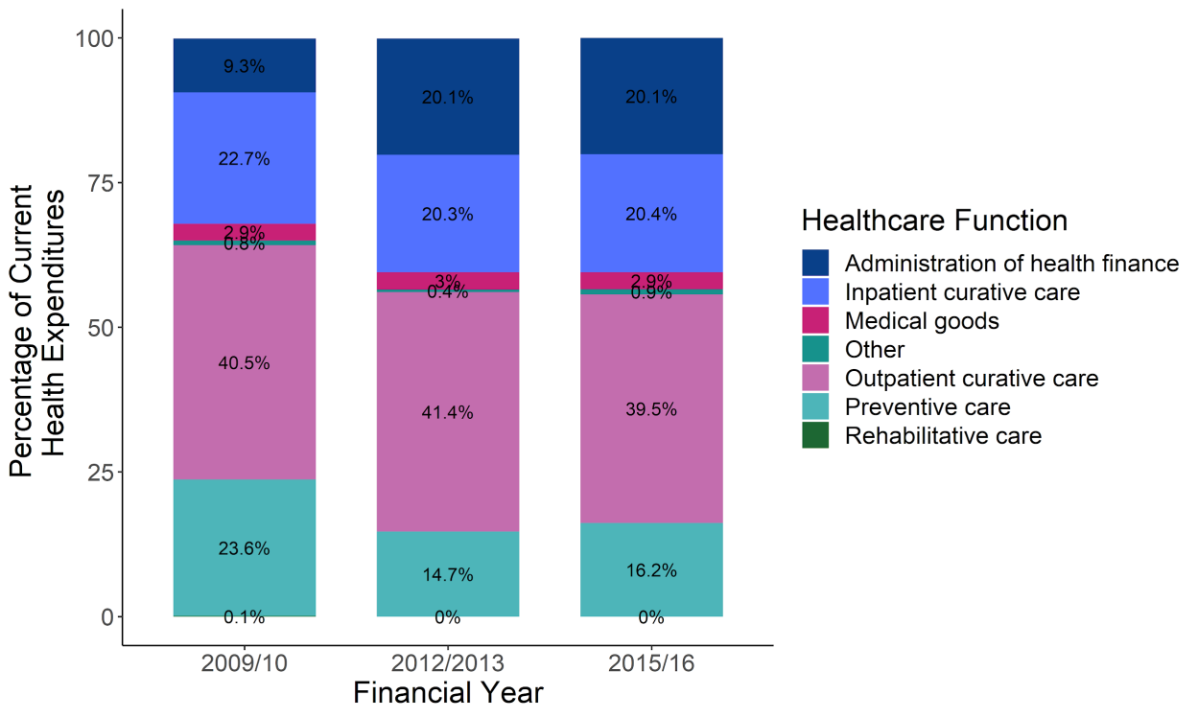

*Source: Kenya National Health Accounts 2015/2016 (MoH, 2019)*

**Purchasing Mechanisms for AGYW and KP Services**

Although the majority (about 95%) of PLHIV enrolled in HIV care and treatment receive services in the public sector or through FBOs, 2% of patients receive care from private sector providers while another 2% either receive care through donor-subsidized franchises or self-fund through private insurance and out-of-pocket payments.

Most HIV money flows to Antiretroviral Therapy (ART) and a range of general and targeted prevention activities. These include the introduction of Pre-Exposure Prophylaxis (PrEP) in the country specifically targeted at KPs and AGYW for HIV prevention (NASCOP, 2020). It is however noteworthy that the private sector lacks access to the free HIV drugs for their patients (PEPFAR, 2020). Roles and mechanisms for social contracting of non-state actors e.g. CSOs are yet to be fully outlined in spite CSOs having the potential to play a big role in efficient purchasing of services.

### Purchasing of commodities for most HIV, KP & AGYW programs is done centrally through KEMSA except for few implementing partners who purchase their commodities separately from private firms.

Purchasing of commodities for most HIV, KP and AGYW programs is done centrally through KEMSA except for few implementing partners who purchase their commodities separately from private firms. KEMSA can procure quality assured medicines through international tender at cheaper rates than international reference prices, leveraging on economies of scale. For instance, the price of some anti-retroviral medicines procured by KEMSA were below Global Fund’s pooled procurement prices by up to 21% (Global Fund, 2018).

### Passive purchasing is still common within the Kenyan health system hence limiting the potential for efficiency gains through purchasing.

The donor agencies and the government are the key purchasers of HIV, KP and AGYW commodities in Kenya. PEPFAR allocated about USD 150 Million to KEMSA in FY19 for commodities as well as supply chain system improvement (USAID, 2020). However, as HIV commodity purchasing functions continue to be integrated into government systems, existing bureaucratic processes that consistently lead to delays should be examined for improvement.

Kenya has prioritized the attainment of universal health coverage (UHC) through the expansion of health insurance coverage by the National Hospital Insurance Fund (NHIF). In 2015, the NHIF introduced reforms in premium contribution rates, benefit packages, and provider payment methods. The NHIF reforms sought to expand population and service coverage and reduce OOP, however the body remains a passive purchaser due to weaknesses in the design and implementation of the reforms. These weaknesses affected its purchasing actions with negative implications for the health system goals of equity, efficiency and quality (Mbau et al., 2018).

**Advocacy Opportunity for Inclusive and Less Bureaucratic Purchasing Systems**

The limited engagement of CSOs and private health providers in the purchasing of commodities for HIV and KP services restricts access to these services. This is further compounded by the bureaucracies within the purchasing systems that engenders in avoidable delays in purchasing. These signal advocacy opportunities for:

1. Integrated and inclusive purchasing arrangements that accommodate CSOs and private health providers;
2. Strengthening the procurement processes to limit redundancies whilst improving efficiency and accountability. The latter could include process automation.

#### 3.2.5. Equity Perspectives

The Constitution of Kenya (2010) entrenches the right to access to healthcare with an emphasis on children and marginalized groups (Republic of Kenya, 2010). CAP 4; 43 (1a) further affords all citizens the right to the highest attainable standard of health, which includes the right to health care services, including reproductive health care. To this end, the government has instituted several measures with a view to ensuring equitable access to healthcare.

##### UHC

In 2017, the Government of Kenya announced its ‘Big 4’ agenda for Kenya, one of which was to achieve universal healthcare (UHC) by 2022. UHC would ensure access for all Kenyans to quality healthcare that covers all health care aspects including preventative, curative and rehabilitative services. To achieve this, the government gazetted an Essential Benefits Package for UHC (UHC-EBP) Advisory Panel in 2018 with the key mandate to define and cost the package of health services to be funded under the UHC agenda. Noteworthy, the UHC benefit package does not designate any services specific to the Key Populations and AGYW beyond general reproductive health services. The four pilot counties- Kisumu, Nyeri, Machakos and Isiolo- were selected to represent the diversity of health challenges in Kenya (Watkins & et al, 2017).

Upon the end of the pilot phase, late 2019, the Government undertook a review of the progress made with a view to refining the implementation and the national UHC package ahead of the roll out to the remaining 43 counties.

The NHIF is anticipated to be the vehicle with which to accelerate the progressive attainment of universal equitable coverage (NHIF, 2018). This goes hand in hand with providing financial protection that would shield individuals and households from financial hardship as they seek medical care. To this end, the government initiated legal reforms within NHIF with a view to improving its business processes and alignment to the UHC implementation aims in the country (Barasa, Chuma, & Wambugu, 2019). The reforms included increased contributions from working citizens, inclusion of outpatient services under the NHIF benefits, strengthening of ICT systems for process automation some and empaneling of more providers within the NHIF network.

“The design and implementation of the pilot UHC program does not consider the specific needs of the priority populations. The system continues to be discriminative to most of us by virtue of our legal status.” – *KP Representative.*

Subsequently, the government allocated Ksh. 20 Billion to the MoH in the 2018/2019 budget, a 48% increase from the previous year’s budget (National Treasury and Planning Report, 2019). Of this, Ksh. 800 million was planned towards insurance for the poor and informally employed, a 14% increase from the previous year. Ksh. 2 Billion was allocated to supplying drugs and surgical supplies, while Ksh. 13.7 billion catered for the free maternity programme, an 8.6% increase from the previous year (Ouma, 2018). The 2019/2020 budget continued to place focus on UHC with Ksh. 47.8 billion being allocated to facilitating UHC as shown in Figure 20 (The National Treasury and Planning, 2019).

**Figure 21: 2019/2020 Ministry of Health UHC Budget**

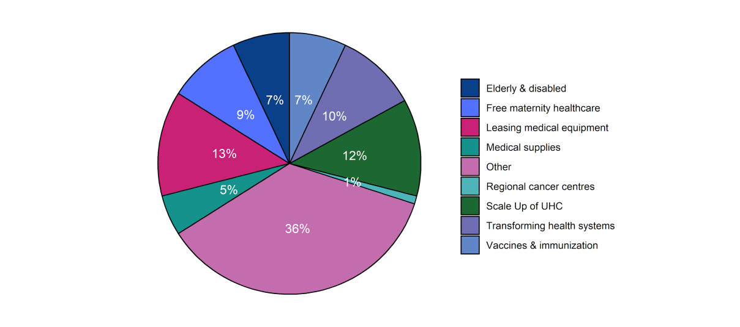

*Source: The National Treasury and Planning, 2019*

**Advocacy Opportunity for Inclusive Design and Implementation of UHC**

The limited coverage scope of the UHC benefit package and the stigmatization of KPs in healthcare provide an opportunity for advocacy for development of a more KP and AGYW sensitive UHC benefits package. It also provides an opportunity for advocacy for capacity building among health workers in the delivery of KP and AGYW sensitive care.

##### 1. Health Insurance Subsidy Programme (HISP)

Health Insurance Subsidy Programme (HISP) was begun in 2014 to cover the poorest of the poor, disabled and elderly (Barasa, Rogo, Mwaura, & Chuma, 2018). A HISP beneficiary is not required to pay for any services out of pocket as the government and donors fully subsidize any incurred costs (Kabia, et al., 2019).

So far, the implementation of HISP has been successful having reached and supported 21,525 poor households and 198,752 elderly and disabled by 2017 (KIPPRA, 2018-2019) with a 45% benefit payout ratio (NHIF, 2018). Cumulatively, the programme has spent over Ksh. 700 million providing these health services (The International Social Security Association, 2019). However, it has faced barriers such as lack of information among beneficiaries which has exposed them to exploitation within the health system in the form of additional fees, shortage of some health services and drugs, lack of feedback mechanisms and high transport fees to reach health facilities (Kabia, et al., 2019).

##### 2. Linda Mama

The Linda Mama scheme provides free maternal and infant healthcare. The Linda Mama program, administered by NHIF, covers care sought at any NHIF registered healthcare facility; all public, 2000 private and 700 faith-based facilities. Indeed, increased uptake of maternal services has been noted with the government assigning Ksh4.1 Billion to Linda Mama in FY2020/21 and targeting 1.36 Million women per year (Ministry of Health, 2017; Ministry of Health, 2018).

##### 3. EduAfya

This is a comprehensive insurance programme for public secondary school students, most of whom are adolescents, launched by the government in 2018. The initiative, administered by NHIF, had an estimated pool of 2.7 million students covered in 2019 (NHIF, 2020). Beneficiaries are entitled to comprehensive outpatient and inpatient care including rehabilitation for drug abuse (Appleford & Mbuthia, 2020). In FY2018/19, the EduAfya scheme had a budget of KES 4 billion based on a premium of KES 1,350 per student per year (PSCU 2018).

**Advocacy Opportunity for Explicit EduAfya Benefits Package**

Whilst EduAfya provides cover to KPs and AGYW in public secondary schools, the scope of cover for sexual and reproductive health is neither clear nor explicit. This results in limited access to the services covered. This provides an advocacy opportunity for explicit rather than implicit benefits package design.

### Against a target of 90% coverage, the coverage levels for Female Sex Workers, MSM and People Who Inject Drugs in the country were 64%, 47% and 44% respectively. - Ministry of Health, 2017

**Equity Perspectives for AGYW and KP in Kenya**

Whilst there are programmes targeting the KPs in Kenya, they suffer from suboptimal coverage with requisite interventions as demonstrated by the National Aids Control Council. Against a target of 90% coverage, the coverage levels for Female Sex Workers, MSM and People Who Inject Drugs in the country were 64%, 47% and 44% respectively (Ministry of Health, 2017)

Noteworthy, PEPFAR in FY20, prioritized needs for the KPs through the “Reimagine, Redesign, and Reboot” program that focused on finding positives, expanding their treatment options and ensuring their adherence and retention. The program is expected to bank on identifying sexual networks, scaling up self-testing and achieving scale and fidelity with partner notification. New KP friendly or dedicated treatment centers would be created in the urban areas of Nairobi, Kisumu and Mombasa. KP programming will also be concentrated on higher burden counties with a heightened focus on MSM (USAID, 2020).

**Table 2: Equity Dimensions in Healthcare Services for KPs and AGYW in Kenya**

| Group | Equity Perspective |
| --- | --- |
| MSM | * Illegal in Kenya vide Section 162 of the Kenyan Penal Code * Kenya Aids Strategic Framework (KASF) 2014-2019 recognizes them as vulnerable * Medical care: Free HIV drugs, Condoms, Lubricants, HPV Screening, STI treatment, and education on HIV (Moyer & Igonya, 2018) * NASCOP responsible for oversight and implementation of MSM care services. * Donors include the Swedish International Development Cooperation agency, the United States President’s Emergency Plan for AIDS Relief (PEPFAR) and USAID |
| PWIDs | * Illegal in Kenya vide the Kenya Narcotic Drugs and Psychotropic Substances Control Act, 1994. * Kenya Aids Strategic Framework (KASF) 2014-2019 recognizes them as vulnerable. * Harm reduction programs: Needle and Syringe Exchange Programs (NSEP), Opioid Substitution Program (OSP), screening and management of Hepatitis B and C, STI testing & treatment, HIV testing, Drug dependence counselling, Patient Education, substance treatment and rehabilitation services (UHC & NHIF) * NACC and NASCOP responsible for policy, oversight and implementation of MSM care services. * Donors include Global Fund, PEPFAR, Mainline Foundation, Community Action on Harm Reduction. |
| FSW | * Though sex work is not classified as illegal by the Kenya Penal Code, the law criminalizes parties who live on the earnings of prostitution and those who solicit or importune for immoral purposes (Kenya Penal Code Section 151-156). * County specific by-laws in some municipalities such as Nairobi, Kisumu and Mombasa criminalize it (FIDA Kenya, 2008; KELIN, 2016). * Kenya Aids Strategic Framework (KASF) 2014-2019 recognizes them as vulnerable. * Medical care: Free HIV drugs, Condoms, HPV Screening, STI treatment, and education on HIV (Moyer & Igonya, 2018) * NACC and NASCOP responsible for policy, oversight and implementation of MSM care services. * Donors include Global Fund, PEPFAR, USAID |
| AGYW | * Kenya Aids Strategic Framework (KASF) 2014-2019 recognizes them as vulnerable. * Services: HPV screening and treatment, sexual health services, contraceptives such as condoms, youth friendly clinics, PrEP, cash transfers for economic empowerment, maternity care etc. * Programs: DREAMS (Determined, Resilient, Empowered, AIDS-free, Mentored and Safe), Linda Mama, EduAfya * Donors include PEPFAR, Global Fund |

**Advocacy Opportunity for Prioritization of KP and AGYW Services**

The recognition and inclusion of KP and AGYWs within the MOH policies such as the Kenya Aids Strategic Framework (KASF) 2014-2019 provides an entry point for sustained advocacy for increased visibility and prioritization of KP and AGYWs agenda in the policy environment.

#### 3.2.6. Accountability

**Table 3: Accountability Systems for Health Financing in Kenya**

|  |  |  |
| --- | --- | --- |
| Accountability Systems for Public & Health Finance in Kenya | | |
| System | Description | Significance & Opportunities |
| a) Laws/ Regulations | | |
| Constitution 2010 Chapter 12 | a. A framework for accountability in the management of public resources. b. Processes and institutions that facilitate enforcement of accountability in public finance management e.g. the Office of the Auditor General (Article 229), the Office of Controller of Budget (Article 228), the Commission on Revenue Allocation (Article 215), the National Treasury, legislative assemblies etc. | Need for amendments to allow: a. Autonomy at facility level on the use of facility generated revenues for health. b. Adequate time for public participation within the budget cycle. |
| PFM Act 2012 | a. Outlines the processes entailed in revenue raising, debt management, revenue allocation, budgeting processes at national and county level. b. Strongly emphasizes and anchors the role of public participation in public finance management in Article 207.  c. Article 15 provides mandate of the national treasury in public finance management in the country.  d. It ensures periodic (monthly, quarterly and annual) financial reporting by all state departments and county governments with a view to ensuring accountability.  Challenge:  a. Deters autonomy of health facilities in the utilization of facility generated revenues  b. Short timelines for public participation within the budget cycle |
| b) Institutions | | |
| i) Government Agencies | | |
| Office of Controller of Budget (OCOB) | a. Established under Article 228 of the Constitution of Kenya, 2010. b. Oversight to the implementation of the national and county budgets. Approval of any withdrawal of public funds, which confirms the expenditure is legal.  c. Publish regular reports on government spending which are submitted to the parliament and are made available to the public.  Challenge:  Delays in publishing spending reports and proposals for public scrutiny. | a. Advocacy for timely publishing of spending reports for public scrutiny and input |

|  |  |  |
| --- | --- | --- |
| System | Description | Significance & Opportunities |
| Office of The Auditor General (OAG) | Established under Article 229 of the Constitution of Kenya, 2010; and Public Audit Act of 2015. Reviews the financial management of public sector entities and projects to ensure propriety and regularity.  Challenge:  Delays in the publication of respective audit reports contrary to the PFM Act 2012 and the Public Audit Act, 2015 (Section 48) | a. Advocacy for timely publishing of audit reports for public scrutiny and input. |
| Commission on Revenue Allocation (CRA) | Established under Article 215 of the Constitution of Kenya 2010. It recommends the basis for equitable sharing of revenues raised nationally between the national and the county governments, and among the county governments.  Challenge: Delays in releasing revenue share recommendation | a. Advocacy for timely release of revenue share reports for public scrutiny and input and review by the other stakeholders. |
| Judiciary | Ensures compliance to set PFM laws by institutions and individuals and provides legal recourse for noncompliance.  Challenge: Delays in the judicial processing of cases | a. Advocacy for fast tracking of PFM accountability related cases. |
| MOH & CDOH | Essential in the formulation, lobbying for approval, oversight and utilization of resources for health.  Challenge: Limited capacity in PFM Systems, MTEF and PBB | Need capacity building on: a. PFM systems including expenditure rules and regulations, audit. b. PBB and MTEF |
| National Treasury | a. Enforces fiscal responsibility principles in public finance management in the country. b. Implementation of the Medium-Term Expenditure Framework (MTEF).  c. MTEF provides for the publishing of the Economic and Fiscal Update, Fiscal Framework Statement, Budget Policy Statement and Corporate Plans of Ministries, State agencies and county governments. d. Implementation of the Integrated Financial Management Information System (IFMIS) with a view to automating the Public Finance Management processes  Challenge: Weak implementation of MTEF and PBB | Need capacity building in implementation of MTEF and PBB |

.

|  |  |  |
| --- | --- | --- |
| System | Description | Significance & Opportunities |
| Parliament & Senate Assemblies | 1. The legislative authorization by the legislative assemblies is enshrined in the Constitution of Kenya, 2010 as well as the Public Finance Management Act, 2012 Aritcles 7-10. 2. They scrutinize the expenditure and revenue proposals of the Executive and decides whether to approve, reject, or amend them. 3. Scrutinize and approve audit reports.   Challenge: Weak legislative capacity as well as limited understanding of PFM systems, PBB, MTEF etc. | 1. Need capacity building on: a. PFM systems including expenditure rules and regulations, audit. b. PBB and MTEF 2. Collaboration in expenditure monitoring at grassroot level. |
| ii) CSO/NGOs | a. Citizens and CSOs are allowed by law to hold the government accountable via personal meetings, public meetings, written statements, media, legal action and public demonstrations. b. Influence the budget by engaging the Executive or the legislature in analyzing budget proposals from the angle of grassroots needs, advocating for more transparency in budget processes, and taking part in local budget-setting processes.  Challenge:  a. Weak capacity for participatory budgeting and interrogation of PFM systems. b. Limited time for budget interrogation c. Redundancies and duplication of CSO interventions hence weak capacity to enforce accountability within the health sector. | 1. Need capacity building on: a. PFM systems including expenditure rules and regulations, audit. b. PBB and MTEF 2. Collaboration in expenditure monitoring at grassroot level. 3. Facilitate capacity development for other stakeholders and the public on PFM systems. 4. Advocacy for PFM reforms to allow adequate time for public participation. 5. Advocacy for stakeholder mapping within HIV/ KP and AGYW programs for effective engagement and accountability. |
| iii) Development Partners | a. Key source of health financing for health in general and for KP and AGYW programs.  Challenge: High Off-Budget financing threatens accountability. | 1. Advocacy for increased on-budget financing of health by donors. 2. Build capacity among stakeholders on accountability for PFM systems 3. Incentivize and support budget transparency, public participation, and government accountability. 4. Provide technical assistance and funding to support accountability in PFM systems. |
| iii) Individuals | a. The Constitution, 2010 and PFM Act 2012 embed public participation in public finance management and throughout the budgeting process.  Challenge: Weak capacity for participatory budgeting and interrogation of PFM systems. | Need capacity building on: a. PFM systems including expenditure rules and regulations, audit. b. PBB and MTEF |
| iv) Media | a. Keep the public and other stakeholders informed and hold the government accountable by reporting on any differences between what is promised in the budget and what is delivered.  Challenge:  a. Weak capacity and limited understanding of PFM systems, PBB, MTEF etc. b. Political influence and bias threatens their integrity and independence. | 1. Need capacity building on: a. PFM systems including expenditure rules and regulations, audit. b. PBB and MTEF 2. Collaboration in expenditure monitoring at grassroot level. 3. Facilitate capacity development for other stakeholders and the public on PFM systems and accountability. 4. Advocacy for media independence for accountability. |
| c) Innovations | | |
| IFMIS | a. Automation of the Public Finance Management processes  Challenge:  a. Weak implementation capacity at user level. b. Lack of goodwill from leaders at user departments. c. System manipulation d. Expenditure management loopholes e.g. locally generated revenues at agency, department and county levels.  e. Poor funding | 1. Need for capacity building on use of IFMIS at all levels. 2. Need for regular system improvements to limit manipulation and ensure integration at requisite levels. 3. Need to incentivise implementation of IFMIS at user level. |

**Advocacy Opportunity for Synergy in the Accountability Systems**

Effective accountability of health financing systems and the budgeting process requires a conducive social, legal and political environment with the requisite enabling laws, policies and regulations (Brinkerhoff, 2004). Synergies achieved through collective coordination amongst the key stakeholders and the existing systems bear a significant potential in strengthening accountability.

## 4. Civil Society Landscape Analysis In Kenya

### Legal Environment

Currently, civil society organizations are governed by the Non-Governmental Organizations Coordination Act. In 2013, the president passed into law the Public Benefits Organization (PBO) Act which was to bring all civil society organizations under one law (The Republic Of Kenya, 2013). However, the PBO Act to date has not been published in the Kenya Gazette and as such cannot be considered to be in force. This means CSOs are still under the mandate of the Non-Governmental Organizations Co-ordination Act 1990 in conjunction with the Non-Governmental Organizations Coordination Regulations (The Republic of Kenya, 1992)and the Non-Governmental Organizations Council Code of Conduct (The Republic of Kenya, 1995).

Under the PBO Act, a PBO Authority consisting of the principal secretary, representatives from the finance and foreign affair ministry and civil society representatives, would be established to regulate existing PBOs in Kenya. PBOs would be encouraged to self-regulate by setting up forums that would enforce standards of conduct and by creating a PBO national federation consisting of all registered PBOs and PBO forums (PBO Act, Section 21).

Under section 7 of the NGO Co-ordination Act, the NGO Co-ordination Board was established in 1992 as a State Corporation to regulate the NGO sector in Kenya. It currently regulates the NGOs registered in Kenya with the assistance of the NGOs Council (NGO Co-ordination Act, section 23). Regulation of NGOs includes facilitating and coordinating the work of NGOs in Kenya to ensure they align with Kenyan laws. In practice however, the board manages the registration of NGOs but carries out little regulation (Hailegebriel, 2010). This is because the board lacks the human resources, finances and technical capacity to oversee all the NGOs in Kenya (Hailegebriel, 2010).

#### a) Registration

Currently, the NGO registration process involves performing a name search, providing a cover letter requesting registration and filling the two required registration forms. This registration must be accompanied by three copies of the constitution signed by the top 3 officials of the NGO as well as a proposed one-year budget. The fee of registration varies between national and international NGOs, Ksh16,000 and Ksh30,000 respectively excluding other expenses such as the name search. Under the PBO Act, a timeline of 60 days for an organization’s registration application to be processed is set (PBO Act, Section 9(1)). However, the current act mentions no such timeline and NGO registration has been known to delay with no reason given (Hailegebriel, 2010). International law such as the Universal Declaration of Human Rights 1948 and the International Covenant for Civil and Political Rights, protect the rights of individuals to form, join and engage with CSOs.

#### b) Operation

The Finance Act 2001 provides tax exemption for organizations that have been established to relieve poverty or public distress or to advance religion or education. Such organizations are awarded a tax exemption certificate valid for five years. Employees of NGOs are still required to pay income tax. Under the NGO Act, NGOs may apply for exemption of levies on custom duty on imported goods. An exemption on custom duty is provided by the Cabinet Secretary (CS) of National Treasury through the board. Exemption from VAT on goods and services required by an NGO for its functioning may also be sought by application through the board to the CS of Finance (The Republic of Kenya, 1992). The PBO Act provides tax exemption for donations, as well as sponsorships and membership subscriptions. No custom duties are charged on products imported for the PBO’s public benefit work and this requires no application. Though the NGO Act offers these tax benefits in theory their

implementation, apart from income tax exemption, is lacking (International Center for Not-for-Profit Law, 2019; Hailegebriel, 2010).

The NGO Co-ordination Act specifies that NGOs cannot become a branch or affiliate with political organizations/groups outside of Kenya but can affiliate with a Kenyan political organization. The PBO Act removes this exception and states all PBOs are not allowed to participate in or support political activities such as fundraising or campaigning for political parties.

#### c) Dissolution

In the event of the dissolution of an NGO, the NGO Co-ordination Act requires a reason to be provided to the board and written consent acquired (The Republic of Kenya, 1992). The assets and property of the NGO are to be disposed by the dissolving NGO. The PBO Act requires a dissolving PBO to transfer its remaining assets to a PBO carrying out similar work.

#### d) Enablers & Barriers

Successful CSO engagement in policymaking and domestic resource mobilization depends on the enablers and barriers encountered:

##### i. Trust

Mistrust of CSOs by the beneficiaries and policymakers has made advocacy more difficult in low-income and middle-income countries (Allison, et al., 2020). This mistrust may be because of misunderstandings or stigma around the topic of advocacy the CSO is undertaking such as a stigmatized disease (Allison, et al., 2020).

##### ii. Competition

Competition between CSOs of similar work for the available grants and resources may fuel further mistrust (Spicer, et al., 2011; Allison, et al., 2020). On the other hand, if CSOs can establish trusted relationships with stakeholder and policymakers, more successful collaborations and resource mobilization have been noted (Allison, et al., 2020).

##### iii. Public Awareness

Public awareness and correct understanding are preconditions of more effective advocacy and scholars have advised key stakeholders such as lawyers, policymakers and social workers be educated on human rights and advocacy (Farrer, Marinetti, Cavaco, & Costongs, 2015).

##### iv. Political Context and Will

The political environment of the country plays a role in this as a government that is interested in public opinion acts as a facilitator to public awareness efforts.

A literature review found that the political and economic environment of a country was the most frequently mentioned barrier to successful advocacy of health equity. This literature review discovered that policymaking prioritized economic policies such as privatization and deregulation over health equity policies (Farrer, Marinetti, Cavaco, & Costongs, 2015). In fact, in countries where the economy was prioritized over other spheres, a more individualized, minimal collective action society towards health equity was noted. These types of societies were hesitant to engage in collective responsibility initiatives and patients were usually blamed for their ill health (Farrer, Marinetti, Cavaco, & Costongs, 2015). This made it difficult for health advocates to gather support from both policymakers and the public. Politically, prohibitory legislation that may hinder the activities of the CSO or make it difficult to engage with the beneficiaries acts as a barrier to successful advocacy (Spicer, et al., 2011). The relationship between CSOs and political parties has been found to be one of the most important facilitators/barriers to the influence CSOs have over policy making in Africa (Robinson & Friedman, 2007).

##### v. Stakeholder Engagement

CSOs ensuring the public has a say in policymaking may be as important as the direct involvement of CSOs in policymaking (Robinson & Friedman, 2007). Facilitating face-to-face meetings between CSOs and policymakers has been shown to increase knowledge and build networks especially if communication between advocacy groups and the government are ineffective (Allison, et al., 2020).

##### vI. Data Integrity

Out of date data is another barrier hindering successful advocacy by CSOs. Without appropriate data, it is difficult for CSOs to know the areas needing their most urgent attention. Up-to-date data and mixed-methods research allow CSOs to create evidence-based strategies and close existing knowledge gaps which are useful for advocacy work (Allison, et al., 2020; Farrer, Marinetti, Cavaco, & Costongs, 2015).

##### vii. Resources

Limited resources are frequently mentioned as a barrier to CSO activity and advocacy. Resources not only include finances but human resources as well (Allison, et al., 2020). CSOs have found sharing advocacy strategies and past experiences amongst themselves is useful as it not only fosters better relationships but builds networks (Allison, et al., 2020; Salazar, 2010).

##### viii. Cross-Sector Collaboration

Cooperation between sectors has also been shown to promote successful policy making (Farrer, Marinetti, Cavaco, & Costongs, 2015).

#### e. Global Best Practice

The global best practices for successful advocacy are hinged on the following factors as posited by the Research and Policy in Development (RAPID) framework in Figure 1 (Court, Hovland, & Young, 2005; Pollard & Court, 2005):

1. Political Context: (Politics and Policy Making)- The extent to which the activities are relevant and aligned to the political context.
2. Evidence: (Research, Learning and Thinking)- The extent to which the CSO contributes to relevant knowledge management and translation.
3. Links: (Media, Lobbying and Networking)- The extent to which the CSO leverages on stakeholder relationships for advocacy, knowledge dissemination, and strengthening relationships.
4. External Influences: (Socio-economic, cultural, international influences & donor policies)- The extent to which the CSO maintains relevance to contextual realities relating to community cultures, resource mobilisation, global health trends and donor relations.

**Figure 1: RAPID Framework adapted to CSO Policy Influence**



*Source: Pollard and Court, 2005*

These practices often include education of stakeholders and the public to raise awareness and increase understanding; evaluations of ongoing and past policies and programs, sharing of resources and information amongst CSOs and improved data quality and presentation (Farrer, Marinetti, Cavaco, & Costongs, 2015; Salazar, 2010; Nutbeam & Boxall, 2008). By being more open on the costs and benefits of implementing policies, CSOs can persuade political leaders that the policies are essential and will not waste country resources (Farrer, Marinetti, Cavaco, & Costongs, 2015). How data and evidence is presented matters; successful advocacy has seen CSOs provide data and research in a way that fits the government’s political interests and context (Nutbeam & Boxall, 2008). If CSOs can be known for having reliable, up-to-date information, their reputation as alternative information sources to policymakers will increase their influence (Salazar, 2010).

## 5. Recommendations

|  |  |
| --- | --- |
| Recommendation | Responsibility |
| Revenue Raising |  |
| * Strengthen tax administration through reforms that ensure equity and efficiency with a view to increasing tax revenues. | Government, Donors, CSO |
| * Prudence in public debt and expenditure management in the quest to expand the resources available for heath (fiscal space for health). | Government, Donors, CSO |
| * Ensure financial protection of the vulnerable in society including KPs and AGYWs through government financing of healthcare. | Government, Donors, CSO |
| * Increase allocations and ring fencing of funds for health by government at both national and county level. | Government, Donors, CSO |
| * Increase government funding and ownership of HIV, KP and AGYW interventions | Government, Donors, CSO |
| * Facilitate inclusion of target interventions for KPs and AGYW within the health system across the levels of government and the sectors to reduce fragmentation | Government, Donors, CSO |
| * Strengthen data management, data integration and knowledge management at all levels | Government, Donors, CSO |
| * Facilitate the integration of funding and implementation of KP and AGYW programs within the health system at both National and County Government levels | Government, Donors, CSO |
| Revenue Allocation & Budgeting | |
| * Build capacity in Public Finance Management, Program Based Budgets and MTEF amongst all stakeholders to strengthen their engagement in implementation. | Government, Donors, CSO |
| * Strengthen efficiency and accountability systems to ensure more health for available resources (maximize value for money). | Government, Donors, CSO |
| * Increase on-budget financing of health by donors | Government, Donors, CSO |
| * Incentivize prudence in public finance management | CRA, Donors, CSO |
| * Institute legal reforms to allow adequate time for public participation within the budget cycle | Government, Donors, CSO |

|  |  |
| --- | --- |
| Recommendation | Responsibility |
| Revenue Pooling | |
| 1. Strengthen accountability and improve business processes within NHIF for efficiency | Government, Donors, CSO |
| 1. Facilitate the implementation and integration of the HIV Trust Fund within the UHC agenda rather than independent implementation. Integration would ensure maximization of efficiencies of pool consolidation. | Government, Donors, CSO |
| 1. Expand the health insurance coverage through aggressive, targeted NHIF recruitment | Government, Donors, CSO |
| Purchasing Arrangements | |
| * Initiate reforms to align reimbursement mechanisms to strategic purchasing. | Government (IRA, NHIF), Donors, CSO |
| * Facilitate integrated and inclusive purchasing arrangements that accommodate CSOs and private health providers | Government (IRA, NHIF, KEMSA), Donors, CSO |
| * Strengthen the procurement processes to limit redundancies whilst improving efficiency and accountability e.g. through automation. | Government (IRA, NHIF, KEMSA), Donors, CSO |
| * Facilitate development of a more KP and AGYW sensitive UHC benefits package. | Government, Donors, CSO |
| * Champion for explicit rather than implicit benefits package design. | Government (IRA, NHIF), Donors, CSO |
| * Build capacity among health workers in the delivery of KP and AGYW sensitive care. | Government, Donors, CSO |
| Accountability | |
| * Institute legal reforms to allow for autonomy at facility level on the use of facility generated revenues for health. | Government, Legislature, Donors, CSO |
| * Build capacity among stakeholders on accountability for PFM systems | Government, Donors, CSO |
| * Facilitate collective coordination amongst the key stakeholders and the existing systems for synergy in strengthening accountability. | Government, Donors, CSO |
| * Build capacity among KPs and AGYW to enable them to tap into available resources and for better civic engagement. Such skills and themes should include: i. Proposal development and resource mobilisation.   ii. Civic education on devolution, legislative processes (national and county level), public participation. | Government, Donors, CSO |
| * Facilitate advocacy for KPs to broaden their interests beyond their specific access needs and actively engage in their civic duty as citizens | Government, Donors, CSO |
| * Build capacity on use of IFMIS at all levels. | Government (Treasury), Donors, CSO |
| * Facilitate regular IFMIS system improvements to limit manipulation and ensure integration at requisite levels. | Government (Treasury), Donors, CSO |
| * Incentivise implementation of IFMIS at user level. | Government (Treasury), Donors, CSO |

## 6. Conclusion

The progressive decline in donor funding for health- specifically for HIV, KP and AGYW interventions which are heavily donor dependent in Kenya- necessitates strategic increase in domestic resource allocation to health to guarantee continuity of care and sustainability of respective interventions. Advocacy for an enabling environment for DRM thus remains a priority with a focus on strengthening macro-economic determinants, budget prioritization of health, efficiency and accountability in resource utilization in health, alongside equity and inclusivity. Additionally, meaningful and impactful advocacy must derive from and build evidence, must speak to priorities within the political economy, and must be driven by the interests of the communities in focus.

## References

Afrocave, 2020; The Process Of Sharing National Revenue In Kenya: (<https://www.afrocave.com/vertical-process-of-sharing-national-revenue-kenya/>)

Allison, D., Kizub, D. A., Cabanes, A., Nakigudde, G., Aguilar, B., Zujewski, J. A., . . . Gralow., J. R. (2020). Breast cancer patient advocacy: A qualitative study of the challenges and opportunities for civil society organizations in low‐income and middle‐income countries. *Cancer, 126*(S10), 2439-2447.

*All the Key Stages in the Budget Process in Kenya*. (n.d.). Retrieved August 26, 2020, from <https://www.afrocave.com/budget-process-in-kenya/>

Barasa, E. W., Cleary, S., Molyneux, S., & English, M. (2017). Setting healthcare priorities: A description and evaluation of the budgeting and planning process in county hospitals in Kenya. *Health Policy and Planning*, *32*(3), 329–337. <https://doi.org/10.1093/heapol/czw132>

Barasa Edwine, Rogo Khama, Mwaura Njeri, Chuma Jane. (2016). Kenya National Insurance Fund Reforms: Implications and Lessons for Universal Health Coverage. *Health Systems & Reform*.

Brinkerhoff, D. W. (2004). Accountability and health systems: toward conceptual clarity and policy relevance. *Health Policy and Planning, 19*(6), 371–379.

Carrin, G., & James, C. (2005). Key Performance Indicators for the implementation of Social Health Insurance. *Applied Health Economics and Health Policy, 4*(1), 15-22. Retrieved August 5, 2020

Chuma, J., & Maina, T. (2012). Catastrophic health care spending and impoverishment in Kenya. BMC health services research, 12(1), 413.

Chuma J, Okungu V. Viewing the Kenyan health system through an equity lens: implications for universal coverage. Int J Equity Health. 2011 May 26;10:22. doi: 10.1186/1475-9276-10-22. PMID: 21612669; PMCID: PMC3129586.

*Commission on Revenue Allocation — Promoting an equitable society*. (n.d.). Retrieved August 3, 2020, from <https://www.crakenya.org/>

*COMMISSION ON REVENUE ALLOCATION RECOMMENDATION CONCERNING THE THIRD BASIS FOR REVENUE SHARING AMONG COUNTY GOVERNMENTS*. (n.d.).

Court, J., Hovland, I., & Young, J. (2005). *Bridging Research and Policy in Development: evidence.* Rubgy, Warwickshire: ITDG Publishing.

Dang, D. Y. (2013). Revenue allocation and economic development in Nigeria: An empirical study. SAGE Open, 3(3), 2158244013505602.

*Division of Revenue and Allocation of Revenue in Kenya*. (n.d.). Retrieved August 26, 2020, from <https://www.afrocave.com/division-of-revenue-and-allocation-of-revenue-in-kenya/>

Djomand G, Quaye S, Sullivan PS. HIV epidemic among key populations in west Africa. Curr Opin HIV AIDS. 2014 Sep;9(5):506-13. doi: 10.1097/COH.0000000000000090. PMID: 25010898; PMCID: PMC4804351.

Farrer, L., Marinetti, C., Cavaco, Y. K., & Costongs, C. (2015). Advocacy for Health Equity: A Synthesis Review. *The Milbank Quarterly, 93*(2), 392-437.

Gotsadze G, Chikovani I, Sulaberidze L, Gotsadze T, Goguadze K, Tavanxhi N. The Challenges of Transition From Donor-Funded Programs: Results From a Theory-Driven Multi-Country Comparative Case Study of Programs in Eastern Europe and Central Asia

Supported by the Global Fund. Glob Health Sci Pract. 2019 Jun 27;7(2):258-272. doi: 10.9745/GHSP-D-18-00425. PMID: 31249022; PMCID: PMC6641812.

Hailegebriel, D. (2010). Restrictions on Foreign Funding of Civil Society. *The International Journal of Not-for-Profit Law, 12*(3).

Health Financing Project. (2016). *Health Financing Profile, Kenya.* Washington DC: Health Policy Project.

“Institute of Economic Affairs.” [Online]. Available: https://www.ieakenya.or.ke/number_of_the_week/kenyaa-s-comparison-of-out-of-pocket-expenditure-on-health-with-its-peers. [Accessed: 10-Aug-2020].

International Center for Not-for-Profit Law. (2019). *Nonprofit Law In Kenya.*

Houérou, L., Taliercio, P., & Robert. (2002). Medium term expenditure frameworks: from concept to practice - preliminary lessons from Africa.

Kamau, N., & Njiru, H. (2014). Community based health insurance schemes: lessons from rural Kenya. Journal of Health Care for the Poor and Underserved, 25(1), 192-203.

Kanthor, J., Seligman, B., Dereje, T., & Tarantino, L. (2014). *Engaging Civil Society in Health Finance and Governance: A Guide for Practitioners.* Health Finance and Governance. Retrieved from <https://www.hfgproject.org/engaging-civil-society-in-health-finance-and-governance-a-guide-for-practitioners/>

*Kenyan Constitution, Chapter Twelve, Part 1, Article 201 to 203*. (n.d.). Retrieved August 26, 2020, from <https://sokodirectory.com/2016/11/kenyan-constitution-chapter-twelve-part-1-article-201-203/>

Maina, T., Akumu, A., & Muchiri, S. (2016). Kenya County health accounts: summary of findings from 12 pilot counties. Futures Group, Health Policy Project.

Mbau, R., Barasa, E., Munge, K., Mulupi, S., Nguhiu, P. K., & Chuma, J. (2018). A critical analysis of health care purchasing arrangements in Kenya: A case study of the county departments of health. The International Journal of Health Planning and Management, 33(4), 1159-1177.

McIntyre D, Meheus F. Fiscal space for domestic funding of health and other social services. Working Group on Financing, Paper 5. London: Chatham House, 2014. (<https://www.chathamhouse.org/publications/papers/view/198263>)

Ministry of Health. (2016). *Health Sector Working Group Report. Medium Term Expenditure Framework for the period 2017-18 to 2019-20.* Nairobi: Ministry of Health, Government of Kenya.

Ministry of Health. 2019. Kenya National Health Accounts 2015/2016. Nairobi, Kenya: Government of Kenya

Munge, K., & Briggs, A. (2014). The progressivity of health-care financing in Kenya. *Health Policy and Planning*. doi: 10.1093/heapol/czt073

Munge, K., Mulupi, S., Barasa, E. W., & Chuma, J. (2018). A critical analysis of purchasing arrangements in Kenya: the case of the National Hospital Insurance Fund. International journal of health policy and management, 7(3), 244.

Mung'ou, T. (2016). *Transforming media coverage of nutrition in Kenya Field Exchange 52.* Nairobi: Field Exchange.

Njeru, P. (2016). *An assessment of integrated financial management information system implementation towards effective management practices in Nairobi and Lamu Counties (Thesis).* Strathmore University.

Nutbeam, D., & Boxall, A. M. (2008). What influences the transfer of research into health policy and practice? Observations from England and Australia. *Public Health, 122*(8), 747-753.

Obadha, M., Chuma, J., Kazungu, J., & Barasa, E. (2019). Health care purchasing in Kenya: Experiences of health care providers with capitation and fee‐for‐service provider payment mechanisms. The International journal of health planning and management, 34(1), e917-e933.

Pablo Gottret, George Schieber. (2006). A PRACTITIONER’S GUIDE HEALTH FINANCING REVISITED. In P. G. Schieber. The World Bank.

Partnership for Maternal, Newborn and Child Health. (2014). *Budget advocacy for improved women’s and children’s health: experiences from national civil society coalitions.* Partnership for Maternal, Newborn and Child Health. Retrieved from <https://www.who.int/pmnch/media/events/2013/progress_report.pdf?ua=1>.

Pollard, A., & Court, J. (2005). How Civil Society Organisations Use Evidence to Influence Policy Processes: A Literature Review. *Overseas Development Institute Working Paper*, 8-11.

*Public Finance Management Consulting | Expertise Global Consulting*. (n.d.). Retrieved August 26, 2020, from <http://expertise.co.ke/>

Robinson, M., & Friedman, S. (2007). Civil society, democratization, and foreign aid: Civic engagement and public policy in South Africa and Uganda. *Democratization, 14*(4), 643-668.

Salari, P., Di Giorgio, L., Ilinca, S., & Chuma, J. (2019). The catastrophic and impoverishing effects of out-of-pocket healthcare payments in Kenya, 2018. BMJ global health, 4(6).

Salazar, L. (2010). Enablers and constraints to knowledge creation, sharing and use: The case of policy advocacy networks. *Vine, 40*(3-4), 362-375.

Spicer, N., Harmer, A., Aleshkina, J., Bogdan, D., Chkhatarashvili, K., Murzalieva, G., . . . Walt, G. (2011). Circus monkeys or change agents? Civil society advocacy for HIV/AIDS in adverse policy environments. . *Social science & medicine, 73*(12), 1748-1750.

Stapenhurst, R., & Titsworth, J. (2002). *Features and Functions of Supreme Audit Institutions. Africa Region Findings & Good Practice Infobriefs; No. 208.* Washington D.C: The World Bank Group.

The Republic of Kenya. (1992). Non-Governmental Organizations Coordination Regulations.

The Republic of Kenya. (1995). Non-Governmental Organizations Council Code of Conduct.

The Republic Of Kenya. (2013). Public Benefits Organization Act.

*The Vertical Process of Sharing National Revenue in Kenya*. (n.d.). Retrieved August 3, 2020, from <https://www.afrocave.com/vertical-process-of-sharing-national-revenue-kenya/>

The World Bank Group. (2017). *Inclusive and Effective Citizen Engagement: Participatory Budgeting, Makueni and West Pokot Counties.* Nairobi: The World Bank Group. Retrieved from <http://documents1.worldbank.org/curated/en/231501494574792952/pdf/Inclusive-and-effective-citizen-engagement-participatory-budgeting-Makueni-and-West-Pokot-counties.pdf>

Tsofa B, Molyneux S, Goodman C. Health sector operational planning and budgeting processes in Kenya-"never the twain shall meet". Int J Health Plann Manage. 2016 Jul;31(3):260-76. doi: 10.1002/hpm.2286. Epub 2015 Mar 18. PMID: 25783862; PMCID: PMC4988384.

Vogus A, Graff K. PEPFAR Transitions to Country Ownership: Review of Past Donor Transitions and Application of Lessons Learned to the Eastern Caribbean. Glob Health Sci Pract. 2015 Jun 17;3(2):274-86. doi: 10.9745/GHSP-D-14-00227. PMID: 26085023; PMCID: PMC4476864.

Wang, V., & Lise, a. R. (2005). *The accountability function of supreme audit institutions in Malawi, Uganda and Tanzania.* Bergen: Chr. Michelsen Institute.

Williamson RT, Wondergem P, Amenyah RN. Using a reporting system to protect the human rights of people living with HIV and key populations: a conceptual framework. Health Hum Rights. 2014 Jun 14;16(1):148-56. PMID: 25474603.

World Health Organization. (2004). Tax-based financing for health systems: options and experiences (No. EIP/FER/DP. 04.4). World Health Organization.

### Annex 1 Laws governing public finance functions in Kenya

|  |  |
| --- | --- |
| Law | Significance |
| The Constitution of Kenya, 2010 | Chapter 12 of the Constitution provides a framework for structures of PFM in Kenya including the establishment of the following: |
| ●      Article 215: Commission for Revenue Allocation |
| ●      Article 228: Controller of Budget |
| ●      Article 229: Office of the Auditor General |
| Public Finance Management Act (2012, 2015) | Outlines the roles, responsibilities of various actors both in government and outside government in managing public finances |
| County Government Act (2012) | Defines the scope of control by both the national and county governments |
| Inter-Governmental Relations Act (2012) | Outlines how the national and county government relate with each other in a collaborative manner for policy development and implementation |
| Specific laws by the County Governments | Outline specific PFM guidelines at county level e.g. the Facility Improvement Fund (FIF) Bill by W. Pokot County in 2019. This law allows hospitals and health facilities within the county to have residual rights over the revenues that they generate. |

*Source: Analysis by the consultant*

### Annex 2: Key Laws Governing Fundraising and Accountability for CSOs in Kenya

|  |
| --- |
| Legislation |
| PBO Act 2013 |
| Constitution of Kenya of 2010; |
| The NGOs Council Code of Conduct [1995]; |
| The Trustee Act, Chapter 167 of the Laws of Kenya [1982]; |
| VAT Act Cap 476 [1990 rev. 2004]; |
| Customs and Excise Act [rev. 2004]; |
| Income Tax (Charitable Donations Regulations) [2007]; |
| Finance Bill, 2018; |
| Sessional Paper No. 1 [2006]; |
| Companies Act Chapter 486; |

### Annex 3: The historical chronology of the evolving nature of health financing in Kenya

|  |  |  |
| --- | --- | --- |
| Year | Policy | Implications |
| Pre-Colonial to 1965 | User Fees in all public facilities | Inequity in access and utilization of healthcare |
| 1965 | User fees removed at all public health facilities. Health services provided for free and funded predominantly through tax revenue | Enhanced access to healthcare for all. |
| 1989 | User fees introduced in all levels of care. | Negatively impacted demand for health care especially among the poorest population |
| 1990 | User fees suspended in all public health facilities. Waivers and exemption put in place to protect the poor and vulnerable. | Increase in utilisation of healthcare |
| 1991-2003 | User fees were re-introduced in 1991, through a phased implementation approach starting from hospital level. Children under five, special conditions/services like immunisation and tuberculosis were exempted from payment. | This presented a major barrier to access coupled with high out-of-pocket (OOP) payment. |
| 2004 | User fees abolished at dispensaries and health centres (the lowest levels of care), and instead a registration fee of Kenya shillings 10 and 20 respectively was introduced. Children under five, the poor, special conditions/services like malaria and tuberculosis were exempted from payment. | Utilisation increased by 70%; the large increase was not sustained, although in general utilization was 30% higher than before user fee removal. Adherence to the policy was low, due to cash shortages |
| 2007 | All fees for deliveries at public health facilities were abolished | No data on the extent to which policy was implemented and no evaluation has taken place. |
| 2010 | HSSF was introduced to compensate facilities for lost revenue associated with user fee removal. Dispensaries and health centres were to receive funds directly into their bank accounts from the treasury. | Possible positive impacts on adherence to fee removal policy and equity. |
| 2013 | Decentralization of healthcare begins. Free maternity services administered by Ministry of Health (MOH) | Increased utilization of maternity services |
| 2015 | Enhanced NHIF premiums and benefits. Free maternity services funds transferred to NHIF as “Linda Mama” program. Health Insurance Subsidies Program (HISP) | Increased access to services.  Regressive contributory mechanism for the informal sector |
| 2016 | County health financing initiatives such as Makueni UHC and “OparanyaCare” in Kakamega County | Triggered similar initiatives across other counties |
| 2017 | The government declares attainment of UHC by 2022 as one of the main agenda | Increased focus on health as well as funding by the government |

|  |  |  |
| --- | --- | --- |
| 2018 | Launch of *EduAfya*, a comprehensive insurance cover for public secondary school students during the duration of study. | Improved access but introduced challenges of dual coverage (As students in *EduAfya* and dependents within NHIF). It also did not prioritize Adolescent Sexual Reproductive Health (Appleford & Mbuthia, 2020) |
| 2018 | UHC pilot program across 4 counties (Machakos, Isiolo, Nyeri and Kisumu) | Improved access to primary care by populations in the pilot counties. |

*Source: Analysis by the consultant*

### Annex 4: Comparison of the 3 generations of the Revenue Sharing Formula in Kenya

|  |  |  |  |  |  |
| --- | --- | --- | --- | --- | --- |
| No | Objectives | Parameters | 1st Formula | 2nd Formula | 3rd Formula |
| 1 | Enhance service delivery | Population | 45% | 45% | 18% |
| Health | 0% | 0% | 17% |
| Agriculture | 0% | 0% | 10% |
| Basic Equal Share | 25% | 26% | 20% |
| 2 | Promote balanced development | Poverty Level | 20% | 18% | 14% |
| Land Area | 8% | 8% | 8% |
| Roads | 0% | 0% | 8% |
| Urban services | 0% | 0% | 5% |
| Development Factor | 0% | 1% | 0% |
| 3 | Incentivize fiscal effort | Fiscal Effort | 2% | 2% | 0% |
| 4 | Incentivize fiscal prudence | Fiscal Prudence | 0% | 0% | 0% |
| Total |  | | 100% | 100% | 100% |

### Annex 5: MTEF Aligned Budget

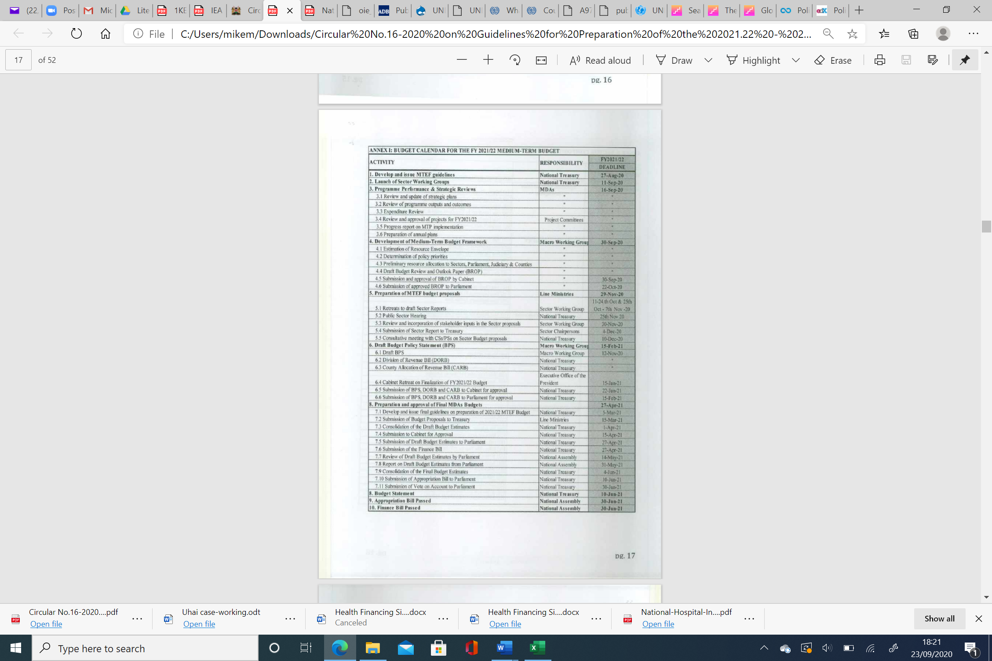

### Annex 6: Budget Cycle

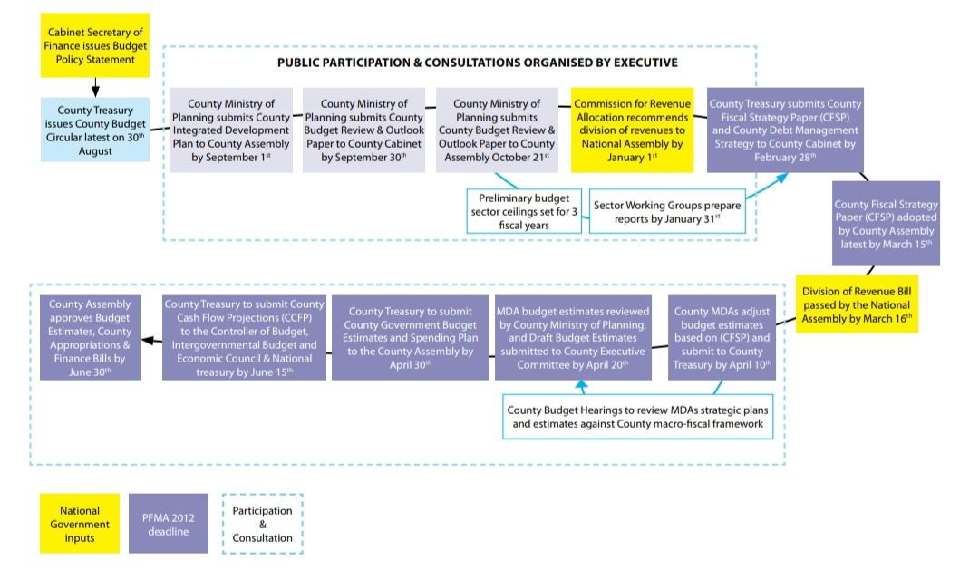

*Source: Adapted from Public Expenditure Review, GOK & UNICEF, 2017*

### Annex 7: Summary and Timelines of Budget Process in Kenya (National Government)

|  |  |  |  |
| --- | --- | --- | --- |
| Step | Who | When | Opportunity |
| Budget Policy Statement |  |  |  |
| Preparation & Submission to Parliament | CS Treasury & Planning | 15th Feb |  |
| Publicize & Publish BPS |  | 1st - 2nd Feb |  |
| Approval | Parliament | 28th Feb- 1st March |  |
| Budget Estimates & Related Documents |  |  |  |
| Submission for approval to Cabinet | CS Treasury & Planning;  Clerk-Parliamentary Service Commission;  Registrar-Judicial Service Commission |  |  |
| Submission for approval to National Assembly | CS Treasury & Planning;  Clerk-Parliamentary Service Commission;  Registrar-Judicial Service Commission | 30th April |  |
| Submission to Parliament of Treasury's feedback on JSC & PSC budgets | CS Treasury & Planning | 15th May |  |
| Publicize & Publish budget estimates | CS Treasury & Planning | As soon as 30th April |  |
| Approval by NA | Parliament |  |  |
| Division of Revenue Bill |  |  |  |
| Preparation and Submission to NA | CS Treasury & Planning | 30th Apr |  |
| Approval by NA | Parliament | 30th May |  |
| Appropriations Bill |  |  |  |
| Preparation and Submission to NA | CS Treasury & Planning | 15th May |  |
| Approval by NA | Parliament | 30th June |  |
| Publicize | CS Treasury & Planning;  OCOB | By 21st July |  |
| Budget Circular | CS Treasury & Planning | 30th August |  |
| Finance Bill & Budget Policy Highlights |  |  |  |
| Submission for consideration by NA | CS Treasury | 30th June |  |
| Approval | Parliament | 30th Sept |  |
| Budget Review and Outlook Paper |  |  |  |
| Preparation & Submission to Cabinet | CS Treasury & Planning | 30th Sept |  |
| Publicize & Publish Cabinet approved BROP |  | 15th Oct |  |
| Approval by Cabinet | Cabinet | 14th Oct |  |
| Submit to National Assembly Budget Cttee | CS Treasury & Planning | 21st Oct |  |
| Approval by Budget Committee | Budget Committee |  |  |
| Publicize & Publish NA approved BROP | CS Treasury & Planning | 5th Nov |  |
| Supplementary Budgets |  |  |  |
| Preparation and Submission to NA | CS Treasury | Within 2 months of 1st withdrawal |  |
| Approval by NA | Parliament |  |  |

*Source: Analysis by Consultant drawn from PFM Act, 2012*

### Annex 8: Summary and Timelines of Budget Process in Kenya (County Government)

|  |  |  |  |
| --- | --- | --- | --- |
| Step | Who | When | Opportunity |
| County Fiscal Strategy Paper |  |  |  |
| Preparation & Submission to County Exec Cttee | County Treasury | 15th Feb |  |
| Preparation & Submission to County Assembly | County Treasury | 28th Feb |  |
| Publicize & Publish | County Treasury | 7th March |  |
| Approval | CEC/ County Assembly | 14th March |  |
| Budget Estimates & Related Documents |  |  |  |
| Submission for approval to County Exec Cttee | County Treasury |  |  |
| Submission for approval to County Assembly | County Treasury; County Assembly Clerk | 30th April |  |
| Submission to CA of Treasury's feedback on County Assembly budgets | County Treasury |  |  |
| Publicize & Publish budget estimates |  | 7th May |  |
| Approval by CA |  |  |  |
| Cashflow Projections |  |  |  |
| Preparation and submission to the Controller of Budget with copies to the Intergovernmental Budget and Economic Council and the National Treasury | County Treasury | 15th June |  |
| Appropriations Bill |  |  |  |
| Preparation and Submission to CA | County Treasury |  |  |
| Approval by CA | County Assembly | 30th June |  |
| Publicize | County Treasury | By 21st July |  |
| Budget Circular | County Treasury | 30th August |  |
| CIDP |  |  |  |
| Submission for consideration by CA | County Planning | 1st Sep |  |
| Publish | County Planning | 8th Sep |  |
| Finance Bill |  |  |  |
| Submission for consideration by CA | County Treasury | 30th June |  |
| Approval | County Assembly | 30th Sept |  |
| County Budget Review and Outlook Paper |  |  |  |
| Preparation & Submission to County Exec Cttee | County Treasury | 30th Sept |  |
| Publicize & Publish Cabinet approved BROP | County Treasury |  |  |
| Approval by County Exec Cttee | CEC/ County Assembly | 14th Oct |  |
| Submit to County Assembly Budget Cttee | County Treasury | 21st Oct |  |
| Approval by County Assembly | County Assembly |  |  |
| Publicize & Publish CA approved BROP | County Treasury |  |  |
| Supplementary Budgets |  |  |  |
| Preparation and Submission to CA | County Treasury | Within 2 months of 1st withdrawal |  |
| Approval by CA | County Assembly |  |  |
| County budget and economic forum for county budget consultation process |  |  |  |

*Source: Analysis by Consultant drawn from PFM Act, 2012*

### Annex 9: Purchasing Mechanisms in Kenya

|  |  |  |
| --- | --- | --- |
| Purchaser | Supplier/ Source | Purchasing Mechanism |
| National Government (MOH) & County Governments | Kenya Medical Supplies Agency (KEMSA) Private Firms | Line Budgets; Global Budgets; Programme-Based Budgets; Fee for Service (FFS) |
| Faith Based Not For Profit (NFP) facilities | MEDS; Private Firms | FFS |
| Not For Profit (NFP) & For Profit (FP) Private Facilities | MEDS; Private Firms | FFS |
| Partners | KEMSA; MEDS; Private Firms | FFS |
| Private Insurance Firms | Public Facilities Private Firms | Capitation/ FFS FFS/ Bundled/ Per-Diem |
| Social Insurance Firms | Public Facilities Private Firms | Capitation/ FFS FFS/ Bundled/ Per-Diem |
| Households | Public Facilities Private Firms | FFS FFS/ Bundled/ Per-Diem |

*Source: Analysis by consultant*

### Annex 10: List of Respondents

|  |  |
| --- | --- |
| Respondent | Number |
| Council of Governors’ Representative | 1 |
| County AIDS and STI Coordinators | 2 |
| County Executive Member for Health | 1 |
| County Director of Health | 2 |
| Implementing Partners | 5 |
| Donor Agencies | 3 |
| CSO Representatives | 4 |
| Healthcare Providers | 3 |

### Annex 11: Key Organizations for CSO Operations in Kenya

|  |  |  |
| --- | --- | --- |
| **Which institutions can offer more information?** | **What the Institution offers PBOs** | **Visiting address & contact** |
| **NGO Co-ordination Board** | * Register, coordinate and facilitate the work of national and international NGOs operating in Kenya * Maintain a register of national and international NGOs operating in Kenya, with their precise sectors, affiliations and location of their activities * Receive, analyse and evaluate the annual reports of NGOs * Advise the Government on the activities of NGOs and their role in development within Kenya | Co-op Bank House, 15th Floor, Haile Selassie Avenue  P.O. Box 44617-00100, Nairobi, Kenya Tel: +254-20-2213938/ 4044/4231/4487/4813/4821 Fax: +254-20-2214801 Email: [info@ngobureau.or.ke](mailto:info@ngobureau.or.ke) Website: [www.ngobureau.or.ke](http://www.ngobureau.or.ke/) |
| **Kenya Council of NGOs** | * Regulates the activities of NGOs with regards to funding, foreign affiliations, national security, training and institutional building. | The National Council of NGOs, Kindaruma Road, off Rose Avenue, off Ngong Road P.O. Box 48278-00100 Nairobi, Kenya No email or website available |
|  |  |  |
| **Ministry of Labour, Social Security & Services** | * Registration of CBOs & SHGs through the Department of Social Development Officer * Development of policies | NSSF Building Community P. O. Box 40326-00100 Nairobi, Kenya Tel: +254 20 2729800 Email: [info@labour.go.ke](mailto:info@labour.go.ke) Website: [www.labour.go.ke](http://www.labour.go.ke/) |
| **The Ministry of Devolution and Planning** | * Offers grants to PBOs (e.g. Women Empowerment Fund, Uwezo fund) * Formulates laws and standards for the PBO sector | Nairobi, NSSF Building, Block A, Eastern Wing 6th Floor. P.O Box 30007-00100 Nairobi, Kenya Box 16936-00100 Nairobi Tel: (+254-020)-2727980 /2252299 Fax: (+254-020)-2734417. Email: [info@devolutionplanning.go.ke](mailto:info@devolutionplanning.go.ke) Website: [www.devolutionplanning.go.ke](http://www.devolutionplanning.go.ke/) |
| **NGOs Support and Resource Center** | * Capacity builds NGOs in project financial managements and monitoring and evaluation * Lobbies for policies for NGOs * Supports NGOs in filling of statutory returns, procurement issues and staff recruitment * Supports NGOs in fundraising and resource mobilisation | Top Brass House, 1st Floor, Next To Naivas Supermarket, Along Outering Road Of Thika Super Highway Nairobi, Kenya Tel: +254 707 376 163 Email: [info@ngos-support.org](mailto:info@ngos-support.org) Website: <http://ngos-support.org/> |
| **East African Association of Grant Makers (EAAG)** | * Facilitates resource mobilization and effective grant making for its member PBOs. * Capacity builds PBOs on endowment building, Foundation building, Grant making and other core areas of interest to grant makers. * Facilitates learning, networking and sharing of knowledge and information among members * Develops and strengthens partnerships with Governments, Civil Society, Private Sector, Development partners, Faith Based Organizations and other Global Grant maker Support Organization on common areas of interest. | Rattansi Educational Trust Building-4th Floor Koinange Street P.O. Box 49626 -00100 Nairobi, Kenya Tel: +254 020 315 773  | or Mobile: + 254 0722 573575 Fax to: +254 020 2244470 Email: [info@eaag.org](mailto:info@eaag.org) Website: [www.eaag.org](http://www.eaag.org/%20%20target=) |

### Annex 12: Glossary

| Term | Definition |
| --- | --- |
| Benefits Package | Generally, the services that the population is entitled to receive for free or with co-payments. It would indicate what to buy, in which form and what to exclude. |
| Budget | The budget is an estimate of Government’s expenditure and revenue within a specified period (usually one year). It shows how the Government plans to make, spend or borrow money. Budgets help to prioritize health needs and interventions that will improve health outcomes for the population. |
| Community- Based Healthcare Insurance Schemes | Community- based health care insurance schemes (CBHIS) are a form of micro health insurance targeted at low-income groups who are excluded from mainstream commercial and social insurance schemes due to high premiums (Kamau & Njiru, 2014). Individuals within the organized body/community contribute to the premiums levied within the CBI schemes for the guarantee of a limited benefit package. The government and donor entities may also contribute to the resources (Pablo Gottret, George Schieber, 2006).  CBHI schemes charge a single flat contribution, either per person or per household (Oxfam, 2013). This way, they are considered regressive with poor households proportionately paying more from their incomes relative to the rich households (Okech, 2014). |
| Devolution | The transfer of decision-making powers and resources from national to subnational governments, which allows for some autonomy and accountability at local levels but also requires clarity on roles and responsibilities at the different levels; adjusting for capacity, including the ability to achieve economies of scale; and an understanding that local and national priorities (e.g. for preventive actions) may differ (Mathauer et al. 2019). |
| Government Health Expenditure (GHE) | The amount of money spent on health by the government (national and county level). |
| Gross Domestic Product (GDP) | The total value of goods and services produced in a country. GDP as an economic indicator is used worldwide to show the economic health of a country. |
| National Health Accounts (System of Health Accounts) | A process through which countries monitor the flow of money in their health sector. The WHO has been looking at the perspective of health financing and coordinating efforts at the global level to produce those estimates for every country. |
| Private Health Insurance | In private health insurance, contributions or premiums are risk-related and are voluntary and contributory. Individuals or groups of individuals pay premiums that are related to their risks only. Private health insurance can be run by for profit companies or non-profit organizations. |
| Social Health Insurance | Social health insurance systems are generally characterized by independent or quasi-independent insurance funds, a reliance on mandatory earmarked payroll contributions (usually from individuals and employers), and a clear link between these contributions and the right to a defined package of health benefits (Pablo Gottret, George Schieber, 2006) |
| Tax-Based systems | Tax-Based systems are those in which more than half of public expenditure is financed through revenues other than earmarked payroll taxes (i.e. to distinguish it from social security or social health insurance), and in which access to publicly-financed services is, at least formally, open to all citizens (WHO, 2015). Tax-based health financing systems generally have three main features. First, their primary funding comes from general revenues. Second, they provide medical coverage to the country’s entire population. Third, their services are delivered through a network of public providers (Pablo Gottret, George Schieber, 2006). |
| Total Health Expenditure (THE) | The total amount of money spent on health from all sources including government, households, donors etc. |
| Universal Health Coverage | All individuals and communities have access to the essential, needed health services (whether promotive, preventive, curative, rehabilitative or palliative) of sufficient quality to be effective in improving health, without suffering financial hardship (i.e. everyone who needs services should receive them, not only those who can pay for them, and the cost of using services does not put people at risk of financial harm (WHO 2019e; 2019f) |

## Acknowledgements

LVCT Kenya is sincerely grateful to the consultancy team that worked on the Situational Analysis Report; Dr. Mike Mulongo (Lead Consultant) Mr. Pascal Irungu (Consultant), and Dr. Lizah Nyawira (Associate Consultant). We appreciate our analysts Ms. Wanja Muriu and Mr. Abubaker Kalule for the in-depth analysis of the background material for the report.

We also acknowledge the contribution and hard work of the core team that toiled to see the success of the development of this situational analysis report. Specifically, we wish to acknowledge Ms. Wanja Ngure (PITCH), Ms. Patriciah Jeckoniah (LVCT Health), Ms. Maryline Mireku (LVCT Health), Ms. Stephanie Finlayson (Frontline AIDS, and Ms. Nyasha Chingore (AIDS and Rights Alliance for Southern Africa) for astute leadership and guidance during the curriculum development.

We are grateful to PITCH for the funding that supported this Situational Analysis Report.

© PITCH & LVCT Health, 2020

**Rights & Permissions**

This Situational Analysis Report was prepared by Dr. Caleb Mike Mulongo, Mr. Pascal Irungu and Dr. Lizah Nyawira on behalf of PITCH & LVCT Health with the support of Frontline AIDS and ARASA. It is therefore a joint copyright of PITCH & LVCT Health, Frontline AIDS and ARASA.

Cover page photo credit: Isla Haddow-Flood, Wikimedia Commons

**Citation:** PITCH (2020). Health Financing Situational Analysis Report: Domestic Resource Mobilization for Key Populations (KPs) and Adolescents, Girls & Young Women (AGYW) in Kenya.

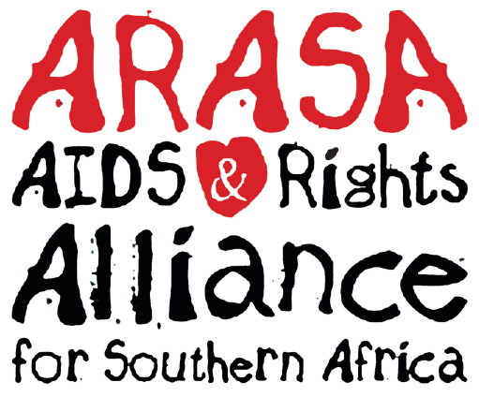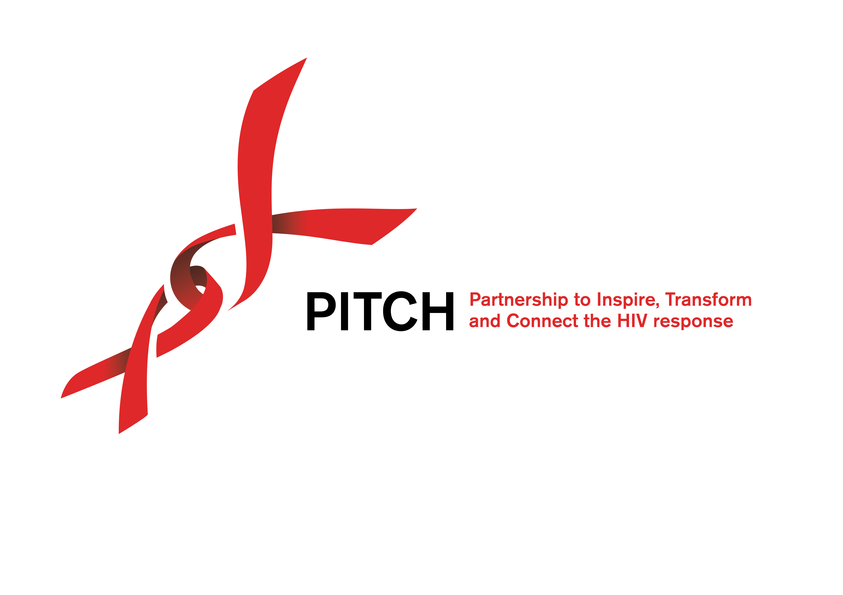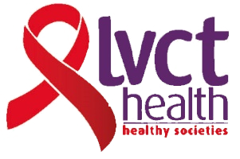

1. The EAC Monetary Union Protocol provides for fiscal convergence criteria, including a ceiling on the fiscal deficit (defined including grants) of 3 percent of GDP; and a ceiling on the gross public debt of 50 percent of GDP in net present value terms.
2. The conversion rate of 108.3 was adopted based on the Central Bank of Kenya indicative exchange rate on 31st August, 2020
3. Off-budget funding refers to revenues, expenditures, or financial transactions that are excluded from the government budget, namely the direct allocations from donors to non-state actors that flow outside of the PFM system. Off-budget funds usually allow for greater flexibility on the part of non-state actors, who in budget execution can bypass cumbersome government processes.
4. USAID and PEPFAR Funded Health Policy Plus in partnership with the Kenya School of Government conducted a training on Program Based Budgeting for an initial 12 counties including Nairobi, Kisumu, Nyeri, Isiolo, Bomet, Mombasa, Makueni, Turkana, Kakamega, Siaya, Migori & Tharaka Nithi